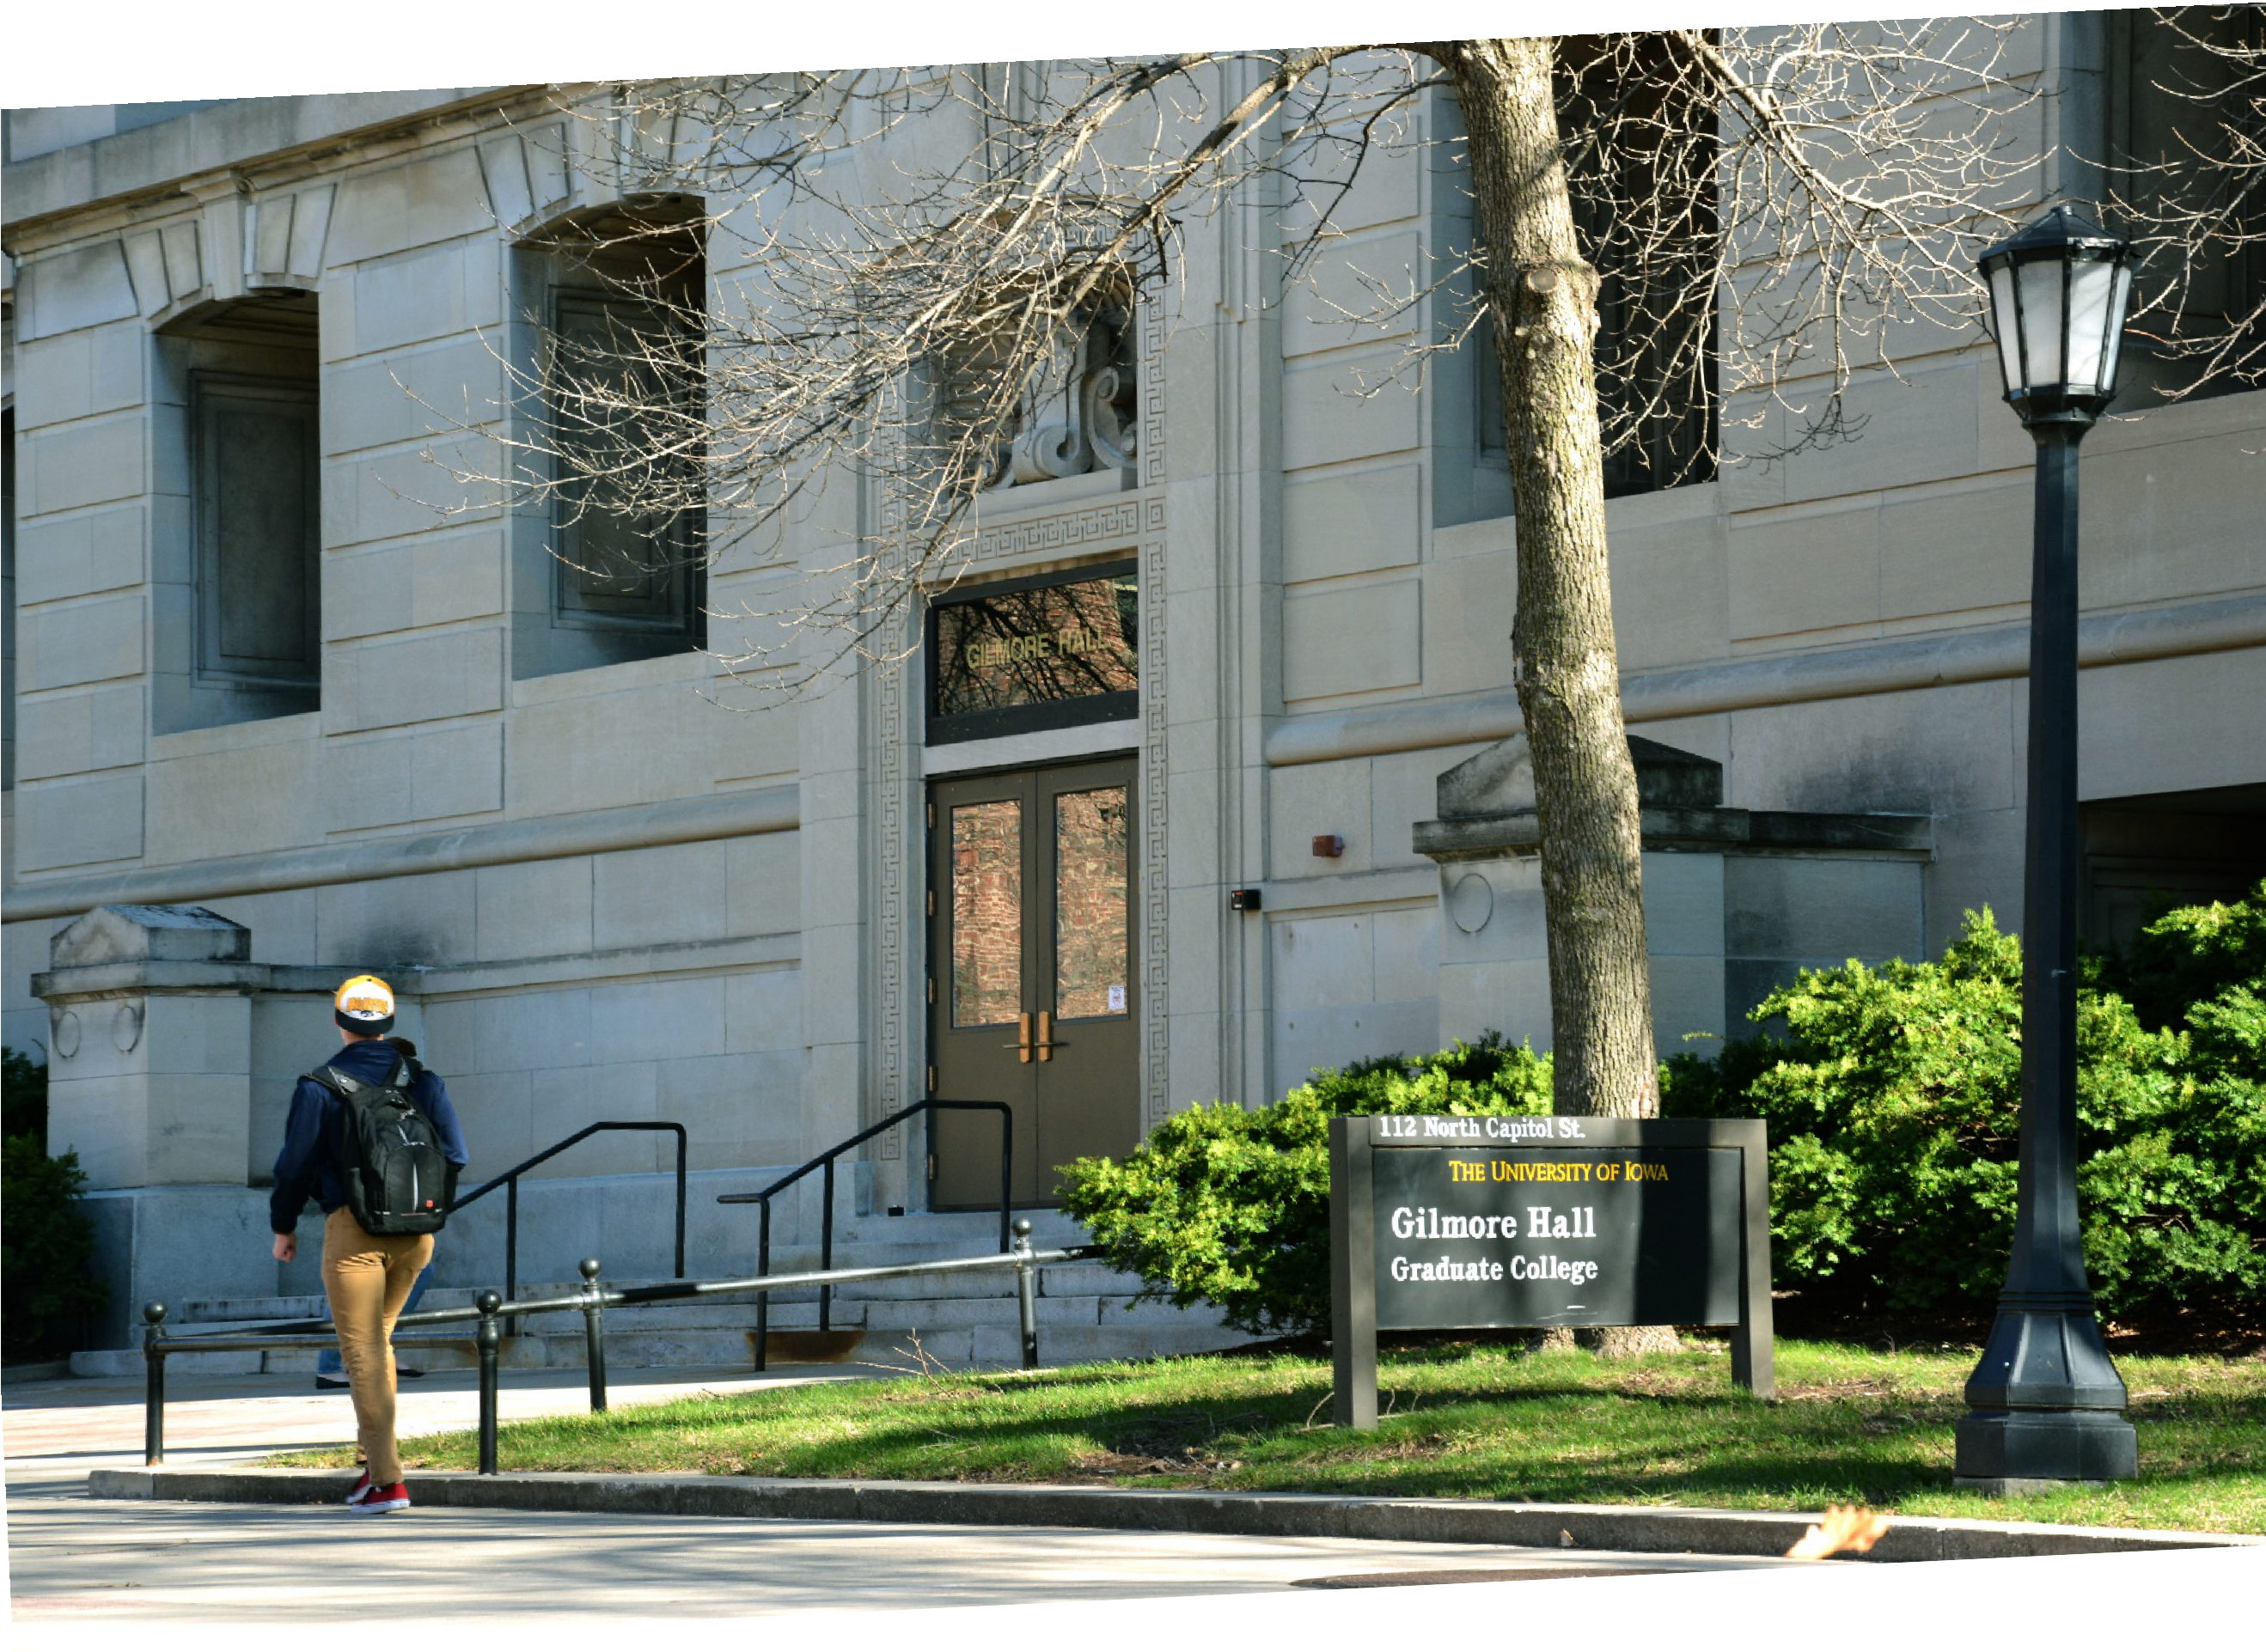


Fall 2015 Graduate College Self-Study

Table of Contents
Executive Summary

- Graduate College Mission, History, and Organization
  - Mission
  - History
  - Organization

- Graduate Education Landscape (2004-2015)
  - Responses to the 2003-04 Review
  - Changes and Innovations in Graduate Education 2009-present

- Graduate Student Success and Distinctive Graduate Programs: The Path Forward
  - Graduate Student Success Initiatives
  - Distinctive Graduate Programs
  - Diversity and Inclusion Initiatives
  - Summary of Future Initiatives

List of Appendices
Appendix A: Graduate College Organizational Chart
Appendix B: Administrative Structure, Academic Departments and Programs, and Governance of the Graduate College
Appendix C: Graduate College Enrollment, Budget, and Outcomes Data Appendix D: Graduate College Review 2003-2004
Appendix E: Task Force on Graduate and Professional Education (2010)

Executive Summary
In this self-study of The University of Iowa (UI) Graduate College, a retrospective look at graduate education is juxtaposed with a 21st century vision for higher education at the graduate level. Nationally, the past decade has been marked by increasing costs, declining budgets, decreases in external funding, and changing student demographics. Locally, higher education faces a mandate to be engaged, efficient, accountable, and of demonstrated value to the state of Iowa.
The most recent UI strategic plan, Renewing the Iowa Promise 2011-2016, articulates broad goals to promote graduate student academic and professional achievement. The Graduate College’s strategic vision for UI graduate education strives to support graduate student success and foster distinctive programs. Three guiding tenets serve as the foundation for this strategic vision. First, Graduate College leadership advocates evidence-based practice and encourages innovation in graduate education. Second, the Graduate College develops policies and procedures that promote graduate student success as measured by diversity and student retention, degree completion, and career placement. Third, the Graduate College is a careful steward of its financial resources. These guiding tenets direct the path forward by promoting graduate student success and fostering distinctive graduate programs.

In order to consolidate and enhance operations, personnel, and efficiency, the Graduate College recently restructured its administrative offices. Two newly reorganized central offices, the Academic Affairs Office (AAO) and the Office of Graduate Development and Postdoctoral Affairs, work in concert to meet the academic and professional needs of graduate students. These two offices now report to a single associate dean and work closely with both internal and external campus partners, such as the Office of Graduate Inclusion (OGI), academic departmental graduate programs, and cross-campus student support offices.
Major Graduate College initiatives on the horizon to promote graduate student success and distinctive graduate programs include:
- Creation of electronic infrastructure to manage student recruitment, enrollment, and retention as well as degree progress and clearance efforts.
- Enhanced professional development and funding services including preparation for careers both in and outside of the academy, application assistance for honorific-funding awards, and implementation of a competencies-based professional development model.
- Continued promotion of diversity and inclusion best practices for underrepresented student recruitment and retention.
- Enhanced infrastructure to support analytics and data-driven decision-making at the program, collegiate, and university levels through regular programmatic review.
The Graduate College is leading an ambitious effort to shape the future of graduate education at UI. The Graduate College recently made administrative changes to

increase its efficacy in both practice and mission. The Graduate College pursues student success and distinctive programs guided by data, policy, and fiscal responsibility. These efforts position the College to renew the Iowa Promise for graduate education and to ultimately ensure the institution’s continued status as an American Association of Universities (AAU) member. Additional infrastructural resources necessary to advance these goals include top-level advocacy for the value and role of graduate education as well as enhanced financial and personnel resources to promote student and program success initiatives.

Graduate College Mission, History, and Organization

  - Mission
The mission of the Graduate College at The University of Iowa (UI) is to foster an intellectual environment conducive to exemplary research, scholarship, and creativity among graduate students, postdoctoral scholars, and faculty. The College makes every effort to ensure that the graduate programs offered by the University are of high quality and stimulate the creation of new knowledge and information, and that these efforts simultaneously benefit both graduate and undergraduate student learning. The Graduate College serves as an advocate for graduate education, allocates resources that support graduate students and programs, promulgates policies and procedures to establish and assess graduate programs, and fosters interdisciplinary programs. Within the context of university aspirations, the Graduate College serves to create an academic and intellectual climate that appreciates and respects diversity, values creativity, and supports the academic potential of each student.
Central to the mission of the Graduate College is its strategic vision of supporting student success and fostering distinctive programs. The guiding tenets of evidence-based best practice, effective policies and procedures, and strategic funding help UI graduate students become the next generation of faculty, researchers, leaders, and innovators. The Graduate College promotes excellence in the academic community with 25 graduate programs ranked among the top 25 best programs in the nation (U.S. News and World Report, 2016). The UI Graduate College leads the nation’s public institutions in high-quality dissertations, with five winners and twelve finalists in the Council of Graduate Schools (CGS/UMI) Distinguished Dissertation Award competition. The Graduate College has increased the number of honorific awards received by students to the highest level ever. In short, Graduate College efforts help ensure UI graduate students are prepared to become part of the highly skilled workforce needed to solve the complex social and economic problems locally, nationally, and globally in the 21st century.

History
Established in 1900, the Graduate College has a history of innovation, which serves as a strong foundation for our contemporary initiatives in graduate education. The University of Iowa was among the first universities to offer MFA and DMA degrees, to accept and foster interdisciplinary research by faculty and students, and to embrace professional degrees at the doctoral level (DPT, DNP, and AUD). At the same time that the UI Graduate College led the creation and acceptance of new graduate degrees in graduate education, it has also long supported more traditional academic programs (e.g., MA, MS, and PhD) as well as professionally-oriented programs (e.g., MSW, MAT, MAC, MCS, MPH, MHA, and MSN). Professional degree programs in medicine, dentistry, law, and business (e.g., MD, DDS, PharmD, JD, and MBA) are conferred by other colleges, but continue to become an important component of dual degree programs routinely pursued by students wishing to enhance their marketability and

expand their professional expertise. The University of Iowa has been an active member of the American Association of Universities (AAU) since 1909, and the current dean of the Graduate College has served as the President of the AAU’s Association of Graduate Schools.

Organizational Structure
The Graduate College administrative structure recently underwent a strategic reorganization to better align resources and personnel with the aim of transforming graduate education at UI. The new structure of the Graduate College and its 12 reporting units and programs is illustrated in an organizational chart (Appendix A). In brief, the college is comprised of Associate Provost and Dean of the Graduate College, John C. Keller, who has led the College since 2000. He is assisted by Associate Dean Sarah C. Larsen (effective 8/2015) and two newly promoted Assistant Deans (Office of Academic Affairs and Office of Graduate Development and Postdoctoral Affairs). A faculty-level Collegiate Administrative Fellow and staff-level Project Manager oversee numerous collegiate initiatives. The Director of Human Resources was promoted to Executive Director of Operations in response to TIER and OneIT initiatives. The College has a dedicated and talented staff, and also serves as the administrative home to 12 interdisciplinary programs and departmental units. Collegiate shared governance occurs through the Graduate Council and the Graduate Student Senate. More detail on administrative structure, academic departments, and programs and governance is provided in Appendix B.

There are approximately 5000 graduate students and postdoctoral scholars enrolled in the Graduate College (Appendix C, Figure C1). Fifty-six percent of graduate students are enrolled in doctoral programs, 38% in master’s programs. The remaining 6% are students in non-degree seeking, credentialing, or certificate-only programs or postdoctoral scholars. The percentage of underrepresented minority (URM) students in the Graduate College has been steadily increasing over the past 10 years to the current level of approximately 12% (see Appendix C, Figure C2). The Graduate College manages the enrollment and degree progress for students in graduate programs from 10 different colleges including the Tippie College of Business, College of Nursing, College of Education, College of Liberal Arts and Sciences, College of Pharmacy, Carver College of Medicine, College of Public Health, College of Dentistry, College of Engineering, and the Graduate College (Appendix C, Figure C3).

Graduate Education Landscape (2004-2015)

It is a disruptive time in higher education generally, and graduate education is not immune to the present challenges. Time-to-degree (TTD) and degree completion have long been used nationally to measure graduate program efficacy; however, in the current climate new indicators are being considered. AAU presidents are reviewing new metrics for graduate education, such as selectivity, student diversity, and honorific funding, as measures of institutional quality and AAU membership. Federal funders (e.g., NSF, NIH, among others) may require outcomes data for professional

development, career preparation, and career placement as success indicators. Fiscal constraints represent a constant challenge. The UI Graduate College was last reviewed in 2003-2004. This section describes the Graduate College response to the findings of the 2003-2004 review (Appendix D) and the vision for addressing the challenges and opportunities presented by the changing landscape in graduate education.

Responses to the 2003-04 Collegiate Review
The Graduate College underwent its first formal review in 2003 (see Appendix D). The final report completed in 2004 identified several recommendations. Two of the major categories of recommendations were graduate student funding and information technology (IT).
Graduate Student Funding. Recommendations were made regarding the 1) distribution of the Block Allocation (recurring allocations to each graduate program made by the Graduate College), 2) creation of summer graduate fellowships, and 3) funding of graduate assistantships. The review committee recommended changes in the Block Allocation to make decisions more transparent and equitable. This was accomplished, but the Block Allocations to graduate programs were subsequently discontinued in 2009. The proposed summer fellowships were created and are now one of the Graduate College’s most successful fellowship programs. Graduate assistantship compensation (e.g., stipends, tuition scholarships) was adjusted as a result of collective bargaining with the graduate-student employee union, COGS. Other changes to graduate student funding included the strategic restructuring of Graduate College fellowships (additional detail below) and the implementation of a continuous registration policy. The general timeline for these changes is shown in Figure 1.

Information Technology. Recommendations were made regarding the 1) increased use of data available through technology to inform collegiate decision-making as well as 2) increased use of web technologies to raise the profile of the Graduate College and facilitation of recruitment efforts, particularly of underrepresented minority students.
Enhanced technological applications available within the University and at the Graduate College in the last few years has driven a renewed commitment to evidence-based decision-making and changes in managing student progress records, which has resulted in greater degree processing automation. These efforts have culminated in the more efficient use of staff time, enhanced operational transparency, and increased data integrity. The Graduate College has plans to tackle a website update in 2016. The last website refresh focused on student/user-centered navigation and content.

Changes and Innovations in Graduate Education 2009-present
Since the last review and collegiate response, the path forward has been guided by a strategic vision focused on promoting graduate student success and fostering distinctive graduate programs. In 2009, the Provost charged a Strategic Initiative Task Force on Graduate Education to lead a comprehensive formal review of all UI graduate programs (i.e., programs with degrees conferred by the Graduate College). The UI Strategic Initiative Task Force on Graduate Education reviewed and evaluated 100+ graduate programs and made recommendations to improve graduate education at Iowa. The

Task Force report (Appendix E) served as a basis for developing the strategic goals for graduate education in the current UI Strategic Plan.

The recommendations of the Graduate Education Task Force led to changes in graduate education at UI including:
    - Closure and creation of new programs.
    - Revision and restructuring of graduate programs across many disciplines.
    - Changes in tuition and fellowship programs.
    - Improved data practices (e.g., maintaining and sharing degree outcome and placement data).
    - Enhanced strategic communication (e.g., campus address on “The State of Graduate Education” in spring 2015).
The Graduate Education Task Force recommended broadening fellowship offerings and concentrating support to high quality programs. With this in mind, the Graduate College further expanded its fellowship programs (including the creation of a summer fellowship for post-comprehensive exam doctoral students) and established the Strategic Initiative Funds (SIF) Program, which invited applications from departments to develop program innovations.
Fellowships were further modified in response to fiscal constraints. The General Education Fund (GEF) budget for the Graduate College includes three major categories: 1) Graduate College units’ salaries and operating budget, 2) Dean’s office salaries and operating budget, and 3) graduate student support (fellowships, scholarships, and graduate assistantships) as shown in Appendix C, Figure C4. The majority of the funds are used to support graduate students. In 2014-2015, substantial reductions in financial aid to the Graduate College resulted in concomitant changes to the Graduate College fellowship programs. The SIF program was discontinued; eligibility for graduate student recruitment fellowships was limited to programs with strong track records of student success (e.g., completion rates of 50% or better); and other funds were reallocated to support high performing students regardless of program (e.g., increased number of summer fellowships). A fellowship for eligible post-comprehensive exam students was also introduced to strengthen timely degree completion. The Ballard-Seashore Dissertation Fellowship program was expanded to include all disciplines (in the past only Humanities and Social Sciences students were eligible), and the award was limited to one academic semester (instead of the entire academic year) so that more students could be funded. The changes in our internal fellowships programs has increased the number of students funded by the Graduate College from approximately 260 in FY15 to approximately 375 in FY16.

The cumulative result of these Graduate College efforts to focus on promoting graduate student success and strategically deploying fellowship resources has been successful, as measured by the following graduate student success indicators (see also Appendix C, Figure C6):

- Average compensation for UI graduate assistants is in the top third of Committee on Institutional Cooperation (CIC) peers, and includes a full tuition scholarship with generous benefits.
- Median time to degree (TTD) for PhD students has decreased from 6.0 to 5.7 years. Notably, significant progress has been made in the Arts and Humanities disciplines.
- Percent PhD completion has increased from approximately 57% to 63%.
An overview of the significant changes in doctoral education at UI from 2004-2015 is provided in Figure 1. The key funding policies and actions are detailed in the timeline of Figure 1 and enrollment trends are shown graphically. A decline in doctoral enrollment can be observed from 2003-2014 with a simultaneous increase in PhDs granted.
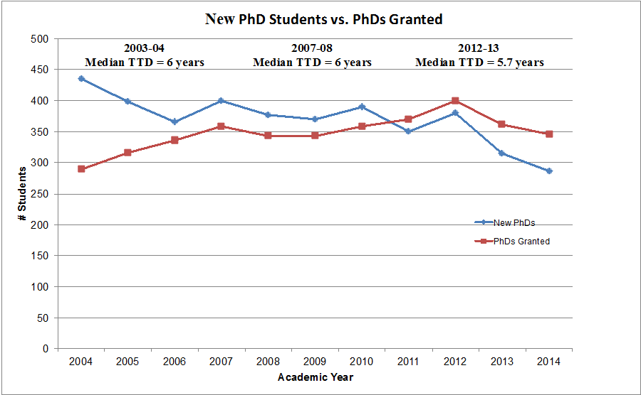



Figure 1. Graph of new PhDs versus PhDs granted and timeline of significant changes in funding and policies related to graduate education at UI
These two trends cross in 2010 when the number of doctorates granted exceeded the number of new PhD students enrolling. This crossover marks an important shift and can be attributed to the impact of Graduate College funding and policy actions, as well as program-specific efforts to increase doctoral degree completion and decrease time to degree. The expectation is that the decrease in doctoral enrollment will stabilize so that

the number of students graduating will better match the number of new students enrolling. At this crossroads in graduate education, as depicted in Figure 1, the Graduate College demonstrates its positive impact on graduate education as a result of its guiding tenets of data-driven decision-making, effective policies and procedures, and fiscal responsibility. It also affirms that the Graduate College is well-positioned to continue leading the campus on the path forward.
3. Graduate Student Success and Distinctive Graduate Programs: The Path Forward
As illustrated, the Graduate College has been successful in catalyzing change and fostering innovation in graduate education across the University. The Graduate College strategic vision is based on the following guiding tenets:
  - Advocating evidence-based practice and encouraging innovation in graduate education.
  - Developing policies and procedures that promote graduate student success as measured by diversity, retention, degree completion, and career placement.
  - Carefully stewarding financial resources.
These tenets will define the path forward as the Graduate College continues efforts to promote graduate student success and support the continued success and the evolution of distinctive graduate programs (Figure 2).

Graduate Student Success Initiatives
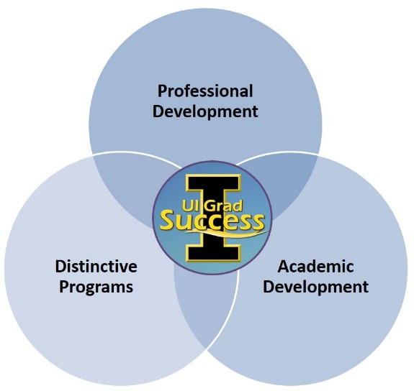
The Graduate College efforts to support graduate student success are student-centered and synergistic, with well-defined benchmarks for academic progress and professional development. National leaders in
graduate education recommend holistic graduate student preparation to meet 21st century educational goals. The recent collegiate restructuring positions the Graduate College to operate effectively in the two most important domains of graduate students’ education and development. The newly reorganized offices in Academic Affairs Office (AAO) and the Office of Graduate Development and Postdoctoral Affairs work in concert to meet the

academic and professional development needs of graduate
Figure 2. Overview of Graduate Success Initiative

students in partnership with UI departmental programs and other campus-partner student support offices.
Looking at the responsibilities and initiatives of each of these offices separately and how they work together reveals the strength of the current collegiate structure. The AAO is

both a central administrative unit responsible for managing students’ degree progress, completion, and clearance as well as a student service office that fosters current and prospective students’ academic success. Recent and forthcoming academic initiatives spearheaded by the AAO will move the Graduate College toward developing and adopting an electronic infrastructure for degree audit, collegiate-level records management, and academic misconduct case management. Electronic records management serves the multiple aims of improving data transparency, security, administration, quality and analysis, as well as ensuring effective business operations and practices. The vision is that these AAO initiatives will guide the Graduate College in developing more effective, efficient and predictive metrics for monitoring and promoting graduate student progress and success.
In addition to managing the successful academic progression of current students, the AAO is the Graduate College unit best positioned to address the 2003-04 Task Force recommendations for centralizing and improving graduate student recruitment.
Recently, graduate admissions at UI went fully electronic. Moving forward, the Graduate College seeks to play a greater role in the recruitment and admission of graduate students. On the recruitment side, the Graduate College participates in regional and national-level (URM) student recruitment events. Every prospective student contact is recorded in the university’s student information system (MAUI). Creating an electronic record of every recruitment contact ensures engaged follow-up and is a recruitment best practice. The Graduate College uses the UI communications dispatch tool to systematically communicate with these prospects through scheduled messaging.
On the admissions side, the Graduate College advocates for a more widespread commitment from academic departments and programs to recruit doctoral students with full funding packages. The Graduate College anticipates developing an academic and professional development planning tool for departments to use with matriculating students. Individual Development Plans, or IDPs, provide students with a much needed roadmap for their studies. Finally, enrollment management is the strategic umbrella under which recruitment and admissions operate. The Graduate College anticipates identifying strategic enrollment targets for both master’s and doctoral student incoming cohorts to ensure institutional effectiveness. Through these collective efforts the Graduate College believes that enrollment management best practices (e.g., strategic student recruiting, full-funding offers, an academic planning tool, and right-sized, nationally, competitive programs) will lead to a higher quality student body with a greater potential of degree completion in a timely manner. Additionally, as the Graduate College continues to review the use of its financial resources, enrollment management strategies will provide improved coordination of funding allocations for graduate students.
The Office of Graduate Development and Postdoctoral Affairs was formed to meet the professional development needs of graduate students and postdoctoral scholars.
Specifically, this office 1) facilitates cross-campus professionalization efforts for graduate students; 2) develops and delivers programming for departments; and 3) counsels individual graduate students on careers and funding. Recent data (shown in

Figure 3) indicate that each year more students are taking advantage of Graduate College professional development opportunities through workshops or appointments. Each of these areas is described below in more detail.
- Fellowship Support: Offers graduate students and postdoctoral scholar feedback and review for all stages of the fellowship process: planning, searching, and preparing a proposal. Students and postdoctoral scholars are able to book one-on-one appointments or attend group workshops.
    - Career Advising: Helps individuals learn more about expanded career options for PhD’s, how to search for jobs, and how to conduct an effective informational interview. Access to Versatile PhD (an online resource for alternative career preparation), reviews of job application materials, including résumés, CVs, and cover letters, is also included.
    - Professionalization Workshops: Focuses on key areas of interest for students, including career development, finding funding, and building networks. The Graduate College staff presents, develops panels, and partners with faculty to present these topics.
    - Professional Online Identity: Up to 92% of recruiters perform an online search of a candidate before staging a face-to-face interview. The Graduate College staff teaches individuals how to build and cultivate a professional on-line identity.
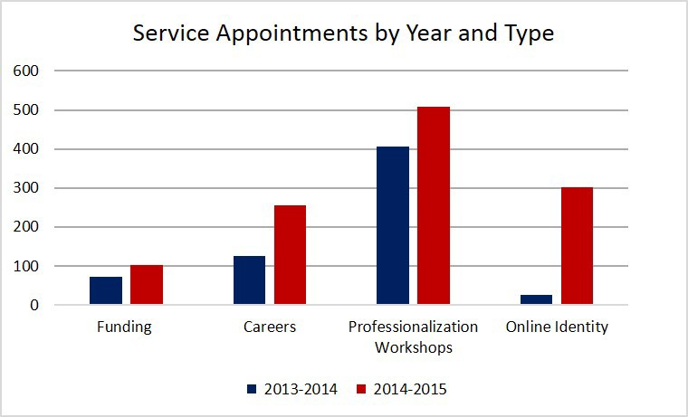
Figure 3. Graduate student use of professional development appointments and workshops
The Graduate College’s career services fill a gap in current PhD preparation. While as recently as a decade ago, the majority of PhDs expected to go directly into academia, many PhDs now seek leadership positions within industry, government, cultural, and non-profits sectors. By assisting students as they prepare for a rapidly changing job market, this office seeks to reduce the time between degree and employment. Services include individual consultations and campus outreach including career advising, job materials review, funding consultation, and professional online identity.

The Graduate College’s fellowships services support students applying for external grants and fellowships. Honorific awards provide support for research, dissertation, travel, or other scholarly activities, as well as bring prestige to students and programs. Experienced staff help graduate students and postdoctoral scholars find and apply for funding from highly competitive fellowships offered by The National Science Foundation, The Ford Foundation, the National Institutes of Health, and others.
Importantly, the Graduate College is also investing in creating a “culture of application” for these nationally competitive opportunities. The Fellowship Incentive Program offers graduate students a scholarship for developing and submitting a nationally competitive fellowship application. Preliminary data for 2015-2016 indicate that the numbers of honorific awards are continuing to increase. Last year, UI had five National Science Foundation Graduate Research Fellowship (NSFGRFP) winners with 17 students applying, and this year, the Graduate College is tracking a record 22 students who have applied to the NSFGRFP.
Graduate College professionalization includes two large annual events: Careers Outside the Academy and the Three-Minute Thesis competition. Careers Outside the Academy is an annual event serving 120+ graduate students. Drawing on Iowa alumni and other PhDs in non-academic careers, the Graduate College offers half-day programming and networking activities for students who are interested in exploring non-academic careers. In 2016, the Careers Outside the Academy (COA) event will expand with grant funding from an NIH supplement to offer top names in industry, non-profits, and communication. The Three-Minute Thesis competition offers a venue for graduate students to present their dissertation research in a clear and compelling way to a lay audience. This event is in its second year and has garnered campus-wide attention.
Both events are developed in coordination with graduate student planning committees and support.
The future of the Office of Graduate Development and Postdoctoral Affairs includes a recent initiative to organize professionalization across campus based on key academic and professional competencies. These competencies include Research and Publication, Teaching, Communication, Careers, Diversity, Funding, Leadership, and Wellness, and bring together over a dozen campus units in planning and implementing programs.
Powered by new features in the UI Events Calendar, these events are cross-promoted to reach the largest possible audience of graduate students.

Distinctive Graduate Programs
Distinctive graduate programs share many similar characteristics, particularly as related to graduate student outcomes. The Graduate College manages graduate student outcomes databases for success metrics such as degree completion, TTD), and initial and current career placements. This information is used to identify best practices, guide decision-making, and monitor progress toward goals. These data are publically available on the Graduate College website. Current and prospective students can gain information about TTD, completions rates, and placement as they consider graduate study. A centerpiece to creating distinctive graduate programs is regular program reviews. Concurrent with the this self-study, the Graduate College is undertaking a

doctoral program review, monitoring progress and initiatives since the 2010 task force report (Section 2.2 and Appendix E).

The longer-term plan is to review programs at five-year intervals to facilitate continued progress toward meeting the goals of graduate education and also to identify and assess broader university needs in graduate education. This process will also allow identification of opportunities to develop innovative and distinctive graduate programs to meet the needs of current and future graduate students. The recommendations of the review will be used to guide future decision-making regarding resource allocation and program revisions and restructuring.

Diversity and Inclusion Initiatives in Graduate Education
Diversity and inclusion are integral to the Graduate College’s overall vision for successful graduate students. The Graduate College’s efforts are centered in the Office for Graduate Inclusion (OGI) but are interwoven across the Graduate College. OGI’s mission is to recruit and retain graduate students from diverse backgrounds
while encouraging academic curiosity and discovery. As a community, OGI students share responsibility, individually and collectively, to achieve the goals of inclusiveness. OGI provides a supportive community where students can explore and manage issues around acclimating to a new environment. OGI encourages students to share strategies, concerns, and encounters related to the challenges of negotiating their graduate studies/education on a predominantly white campus. OGI has recently developed programming that focuses on scholar activism, public engagement, building an inclusive campus community, and tips and strategies for navigating the academy. OGI has a student advisory council to ensure students’ voices are at the center of guiding its work on campus inclusion.
The Summer Research Opportunities Program (SROP), launched in 1986 and hosted by OGI, is an award-winning program designed to provide promising underrepresented undergraduate students with in-depth research experiences. The SROP program strives to prepare young investigators to achieve their goals of pursuing graduate work and of becoming tomorrow's academic leaders as faculty, or to pursue successful careers in government, business, and non-profit agencies. Students receive first-hand exposure to the graduate school experience and to faculty life by being paired with a faculty mentor whose work is closely related to their academic interests and career goals. In summer 2017 the program will be expanded to include undergraduate students majoring in a humanities field through collaboration between CIC schools and Associated Colleges of the Midwest (ACM) institutions. The UI SROP program boasts 90 + PhDs completed as well as many master’s and professional degrees from 755 participants since 1986.
The Graduate College also partners with many different campus and external entities to diversify the graduate student body at UI. This includes providing matching funds to support grants such as the Graduate Areas in Assistance of National Need (GAANN) program in several different departments including Mathematics, Chemistry, Education, and Engineering.

Recently, the Graduate College received a grant from the Council of Graduate Schools (CGS). The CGS Diversity Initiative in Minority Attrition and Completion (DIMAC) grant project called attention to specific interventions and best practices for improving retention of underrepresented minority (URM) students. The DIMAC report provides completion rates, attrition rates, time-to-degree and time-to-attrition of URM STEM doctoral students using data spanning academic years 1992/93 to 2011/12. There are some data to suggest that from the earliest cohort to the most recent, there have been slight improvements in completion outcomes. CGS has now released a white paper on the results and lessons learned from the 22 participating institutions. The Graduate College will share the DIMAC results in order to improve recruitment, retention, and degree completion of not only URM students, but all graduate students at Iowa.

Summary of Future Initiatives
Since the last formal review, the Graduate College has addressed many of the challenges confronting graduate education. The College has adapted policies and procedures, acted upon recommendations from the Graduate Education Task Force 2010, revised resource allocations to support student success initiatives, and substantially reorganized the collegiate administrative and academic offices to promote graduate student success and foster distinctive programs.
The Graduate College is poised to make substantial contributions to further improve graduate education opportunities, thereby solidifying UI’s AAU status. The primary ongoing initiatives include:
    - Development of electronic infrastructure for graduate student academic affairs to better manage recruitment, enrollment, and retention efforts.
    - Enhanced professional development and funding services including preparation for careers both in-and-outside the academy, increased honorific funding, and the development of professional competencies.
    - Continued promotion of diversity and inclusion best practices for recruitment and retention.
    - Enhanced infrastructure for data-driven decision-making at the program, collegiate, and university levels through regular programmatic review including establishment and sharing of program best practices.
The Graduate College works closely with campus partners, including departments, programs, and other student support offices, to advance these initiatives. In order to continue on the ambitious path of advancing graduate education initiatives at UI, additional resources are necessary. This investment would include enhanced advocacy for the value and role of graduate education, additional financial resources to promote student success initiatives and support distinctive programs, and additional staffing to move these initiatives forward.

Graduate College Self Study Fall 2015

List of Appendices
Appendix A: Graduate College Organizational Chart
Appendix B: Administrative Structure, Academic Departments and Programs, and Governance of the Graduate College
Appendix C: Graduate College Enrollment, Budget, and Outcomes Data Appendix D: Graduate College Review 2003-2004
Appendix E: Task Force on Graduate and Professional Education (2010)

Appendix A: Graduate College Organizational Chart

l

ThEfimGRADUATE

UNIVERSl1Y
OFlOWA

secretary IV
Kathy Gerling

Associate Provost tor Graduate and Professional Education and Dean
Pro.iecl Manager
Liz Crooks
-11
John C. Keller
-
�
r---
Assisrant Dean of Graduate Development & Postdoctoral A/fairs Jennifer Teitle
�-
Edu Services supp Asst Je,nnlfer
craWford
�-
- -
I
�.-
I
I
wrner/Editor
John Riehl
Director of External Relations
Kim Chickering
I
25%
I
I I
I
,--
Posfdoctora J
Scholars
E. Savelkoul
A Schott
�-
Associate Deans for Graduate & Postdoctoral Affairs
Center for the BooK
Applied Mathematica I &
computational Science
lnternationa I Writing
Program
Genetics
Directors of Graduate Human Toxicology
studies
School of Library and
Information Science
Immunology
Graduate Council
School of Urb'an and
Regional Planning
Informatics
Postdoctoral Education
Ad"lisory Committee
Molecular and Cell Biology
University of Iowa Press
Neurosciences

Acad Affairs CoorrJ;n;;,to, Anne Sparks
Assistant De an of Academic Affairs
HeldI Arblsl-Kelm

Faculty Fellow Shelly Campo Scholarly Integrity & Postdoctoral Affairs
lnterdlsclpllnary Graduate Degree Programs

Oapartmants/Programs

Advisory Committees

Director of Into Technology
Andy Jenkins
Executive Director of Operatio11s
Donna Welter
Administration, Finance, HR and
Fellowships

Associate Dean for Academic & Adminisfrattve Affairs
Sarah Larsen

Diversdy & lncluskJn Coordinator Diana Sproles

Admissions & Enroll Serv Specialist Joseph Henry

AcadAffairs Coordinator Erin Kaufman

AdmlnServ coord
P. Meintel

Programming Operations Prog coord Joe Cannella

Secretary Ill
Cindy Fetters

Web Conten John Riehl 75%

Application Developer Matthew Arant

Administrnlol; HR & Finance Sandy Gay

17

Appendix B: Administrative Structure, Academic Departments and Programs, and Governance of the Graduate College
The Graduate College administrative structure was recently reorganized so that resources and support could be better aligned with the goals of the Graduate College. The main functions of each of the administrative offices are described below. Brief summaries of the 12 academic programs housed in the Graduate College are provided. An overview of the role of the governance structures includes the Graduate Council and the Graduate Student Senate.

B1 Administrative Offices
Academic Affairs Office (AAO): The AAO is responsible for the following aspects of graduate student academic progress and success:
      - Degree Progress and Completion
      - Student Record Management
      - Thesis and Dissertation Support and Examination
      - Academic Advising and Academic Success
      - Policies and Procedures
      - New Degrees and Curricula
      - Recruitment and Admissions
As a central administrative unit of the Graduate College, considerable AAO staff time is devoted to managing degree progress and completion. These functions will be transitioned to an electronic infrastructure (MAUI) such that, with these mission central administrative efficiencies gained, valuable personnel time can be redeployed to serve collegiate-level student success goals.
In addition to its administrative work, the AAO contributes to the Graduate College’s mission of student success by managing the following initiatives:
      - oversight for the planning and execution of the annual New UI Graduate Student Orientation and Welcome event(s)
      - provision of thesis and dissertation support, which includes technical assistance with formatting, answering scholarship questions and providing resources, and manuscript examination to improve the professional appearance and quality of students’ academic work
      - administration and promotion of combined degree programs, including the undergrad-to-grad (U2G) programs
      - planning of academic success professional development offerings
These support services, in addition to the academic advising the AAO provides, contribute to the model for graduate student success promoted by the Graduate College.
The AAO is also responsible for the rules and standards of graduate education including academic misconduct, as well as the creation and revision of new graduate degree programs and curricula at UI. In this capacity the AAO enforces, proposes, interprets, and applies collegiate policy regarding degree progression, examination, and completion requirements for approximately 1500 graduates each year. The AAO also provides extensive consultation and review of all degree program actions (e.g., creation, closure,

revision, name changes) for graduate programs and departments across campus. The AAO is also responsible for participating in academic program reviews for CLAS and for the Graduate College programs.

Office of Graduate Development and Postdoctoral Affairs: The Office of Graduate Development and Postdoctoral Affairs promotes a holistic approach to graduate student and postdoctoral scholar preparation. Whether the student’s goal is a career in academe, industry, government, or elsewhere, professional development expands options and makes students more attractive to employers by developing transferable skills. Staff in this area collaborate with other campus offices to deliver professional development workshops and promote services for academic writing, teaching skills, and work-life balance. Staff members advise graduate students on preparation of external funding materials and guide the development of job applications, including cover letters, curriculum vitae, and resumes. These services are provided both individually and to a variety of departments, programs, and groups across campus. This office also coordinates a conference on alternative careers for doctoral students and a Three-Minute Thesis (3MT) competition for graduate students.
Office of Postdoctoral Scholars (OPDS): The OPDS serves 300+ postdoctoral scholars at the University of Iowa, as well as their faculty supervisors, departments, and colleges where they conduct their research activities. OPDS offers a variety of services (e.g., campus orientation, weekly electronic newsletters, and professional development programming) in conjunction with the Office of Graduate Development and Postdoctoral Affairs. OPDS has also encouraged more networking among postdoctoral scholars on campus and helped facilitate the formation of the UI Postdoctoral Association (UIPDA).
The OPDS works collaboratively with colleges, departments, and faculty advisors to ensure hiring and salary practices meet federal guidelines. OPDS is currently collaborating with Committee on Institutional Cooperation (CIC) institutions on training grants to promote the success of underrepresented postdoctoral scholars. The CIC (Big Ten plus the University of Chicago) received funding from the National Science Foundation (NSF) to support these efforts. Associate Provost and Dean John Keller serves as the co-Principal Investigator for the Alliance for Graduate Education and the Professoriate (AGEP) Professorial Advancement Initiative (PAI). The PAI seeks to address facilitate systematic multi-institutional cultural change designed to increase the progression of URM postdoctoral scholars into the professoriate.
Whereas AGEP addresses the needs of URMs in scientific fields, the second grant from NSF reaches a broader audience. National Research Mentoring Network (NRMN) includes URMs, and economically and geographically disadvantaged individuals in the sciences and social sciences.
Office of Graduate Inclusion (OGI): OGI provides outreach and professional development programming for underrepresented graduate students, promoting retention and academic success. OGI offers a supportive environment where students can safely talk about managing the process of acclimation to a new environment, and share their particular strategies, concerns, and encounters regarding the challenges and successes of negotiating graduate education. In addition to the services described in Section 3.3, the

Graduate College hosted underrepresented undergraduate students with support from a McNair Scholars Program.
Graduate College Information Technology (GCIT): CGIT, like IT services in the rest of the University, is in a period of change. As the OneIT efforts on campus drive changes, GCIT is engaged in the projects, participating and leveraging new and changed services to meet the information technology needs of the Graduate College and its units. The Graduate College relies heavily on institutional data to drive its strategic and decision-making processes. GCIT functions as an integral part of these processes by acquiring, processing, and helping to interpret data from various institutional sources. The expertise provided has helped drive change in fellowship funding, program evaluation, thesis/dissertation requirements and submission, and student recruitment. GCIT also helps our academic units innovate, enabling outreach like distance education for teacher librarians and writing MOOCs run by the International Writing Program that reach an international audience. The Graduate College is also responsible for providing oversight of national accreditation activities and filing those reports with the Board of Regents. GCIT delivers data necessary for the Graduate College to meet its responsibilities with respect to national accreditation.
Office of External Relations: The work undertaken by the Office of External Relations is an integral part of sharing the resources developed by the Graduate College. The office shares stories of discovery by University of Iowa graduate students and faculty whose interdisciplinary work uncovers knowledge and provides practical solutions for everyday problems. The staff shares these success stories with a diverse audience, including potential and current students, alumni, prospective and current donors, legislators, faculty and staff, the media, and other stakeholders. The office strives to increase awareness, importance, and support of graduate education across campus and beyond through strategic, collaborative work with UI Communications and Marketing as well as through traditional and social media channels.

Office of Finance and Human Resources (OFHR): The Office of Finance and Human Resources consists of three Professional and Scientific staff members, Executive Director of Operations, Administrative Services Manager, and Educational Support Services Coordinator who provide oversight of all personnel and financial management for the Graduate College and its 12 interdisciplinary programs and departmental units. The College budget is approximately $19 M in general education funds and $8 M in non-general education funds. The College has 22 faculty, 44 Professional and Scientific staff, and seven merit staff members, two Postdoctoral Research Scholars, and a number of graduate assistants and hourly student assistant positions.
OFHR is responsible for administrative support in all areas of University policies, procedures, and financial and personnel management including the hiring of faculty, staff, and students. In addition to those responsibilities, OFHR administers the graduate assistantship tuition scholarship program for all units on campus (approximately 2400 scholarships per semester) and administers the Graduate College Internal fellowship programs. OFHR assists students, faculty, and staff with questions and concerns relating to the fellowships, research assistantships, and tuition scholarships. Departments,

programs, and other administrative offices interact with the OFHR regarding policies and procedures for Postdoctoral Research Scholars and Fellows.

B2 Graduate College Academic Departments and Programs
Stemming from its historical relationships with the Office of the Vice-President for Research, the Graduate College serves as a focal point for a number of graduate level interdisciplinary degree programs and activities. Together, these 12 units foster a broad interdisciplinary perspective on the creation and delivery of literary work along with a commitment to engagement with and service to the public. Over the last 10 years, these programs have seen a steady and significant increase in external funding (Appendix C, Figure C5).

Interdisciplinary Graduate Degree and Certificate Programs: The Graduate College awards master’s and doctoral degrees in its interdisciplinary graduate degree programs in a breadth of areas (Applied Mathematical and Computational Sciences, PhD; Genetics, PhD; Human Toxicology, PhD; Immunology PhD, Informatics, PhD; Interdisciplinary Studies, MA and PhD; Cellular and Molecular Biology, PhD; Neuroscience, PhD; Library and Information Science, M.S.; Urban and Regional Planning, MA, MS; Book Arts, MFA). The Graduate College’s administration of interdisciplinary departments and programs has led to expansion of interdisciplinary activity on campus and collaborations on faculty appointments with other colleges.

School of Urban and Regional Planning (SURP): For 50 years, SURP has offered an accredited high-quality professional-oriented master’s degree program in urban and regional planning, which has broad concentrations in economic development, geographical information systems, land use and environmental planning, transportation, and housing development. One of its major accomplishments was the development and launch of the Iowa Initiative for Sustainable Communities (IISC). Initially funded by a Better Futures for Iowans (BFI) grant, the IISC develops projects that address community priorities while engaging students in impactful experiences throughout the state, the IISC pursues a dual mission of enhancing quality of life in Iowa while transforming teaching and learning at the university. The partnerships between students, faculty, and community members that are facilitated by the IISC draw stronger connections between UI and the state, advancing the university’s strong commitment to mutually beneficial engagement with Iowa communities. The impact is truly state-wide, ranging from projects in Muscatine to Sioux City. Recently, the IISC became part of the Office of University Engagement in the Provost’s Office in order to expand its reach.
School of Library and Information Science (SLIS): SLIS has a long tradition of service to the scholarly community and the public as curators of the cultural record. SLIS is well positioned to contribute in the dynamic academic and professional world, and is building upon its American Library Association accredited master’s program in the training of library professionals. A hallmark of the program is the significant expansion of the Teacher-Librarian initiative – funded by the Institute of Museum and Library Services (IMLS) – which allows place-bound teachers to advance their careers.
Center for the Book (UICB): The UICB is a unique program that joins training in the techniques and artistry of bookmaking with research into the history and culture of books. Staffed by artists, scholars, critics and craft workers, the UICB fosters a remarkable dialogue between the book arts and book history. Notably, the UICB is the only academic

program in the United States that focuses on teaching and producing traditional Western-and Japanese-style papers and techniques. This is the result of efforts by then director of the papermaking facilities (and now current Director) Professor Timothy Barrett. Barrett is also a 2009 recipient of a MacArthur Fellows Program, an unrestricted fellowship awarded to talented individuals who have shown extraordinary originality and dedication in their creative pursuits and a marked capacity for self-direction
International Writing Program (IWP): IWP is a unique conduit for the world’s literatures, connecting established writers from the international community, bringing international literature into the classroom, and inculcating cultural exchange through reading tours. In addition to hosting over 30 international writers as part of Fall Residency, the IWP is actively involved in developing a series of Massive Online Open-Enrollment Courses (MOOC) such as “How Writers Write.”
University of Iowa Press (UIP): Established in 1969, the UIP plays a vital role as publisher of scholarly and creative works that do not typically attract great commercial attention. The UIP is a well-regarded academic publisher serving scholars, students, and readers throughout the world. As the only university press in the state, UIP is also dedicated to preserving the literature, history, culture, wildlife, and natural areas of the Midwest. For scholars and students, UIP publishes reference and course books in the areas of archaeology, American studies, American history, literary studies, theatre studies, and the craft of writing. For general readers, materials published include the winners of the Iowa Short Fiction Award and the Iowa Poetry Prize, poetry anthologies, books on the archaeology and natural history of the Midwest, cookbooks, letters and diaries, biographies, memoirs, regional history, and collections of historic and contemporary photographs.

B3 Graduate College Governance
Graduate Council: The Graduate Council serves as the executive committee of the graduate faculty. The Graduate Council consists of 13 members elected from the graduate faculty, four graduate students chosen by the Graduate Student Senate for one-year terms, and the deans of the Graduate College as ex officio non-voting members. Faculty representation on the Graduate Council consists of 11 elected collegiate representatives (one representative each from Business, Dentistry, Education, Engineering, Medicine, Nursing, Pharmacy, and Public Health and three from the College of Liberal Arts and Sciences) and two at-large representatives elected by the graduate faculty as a whole.
The Graduate Council assists and advises the Dean on college policy, rules, regulations, and academic programs.

Graduate Student Senate (GSS): The GSS is a representative, administrative, and service organization for graduate students at UI. GSS serves as the voice of graduate students to the collegiate and university administration and to the broader university community. The GSS organizes the annual University-wide Jakobsen Graduate Conference and distributes graduate student conference travel funds that are provided by the Graduate College.

Appendix C – Graduate College Enrollment, Budget and Outcomes Data

Figure C1. Graduate Enrollment Trends

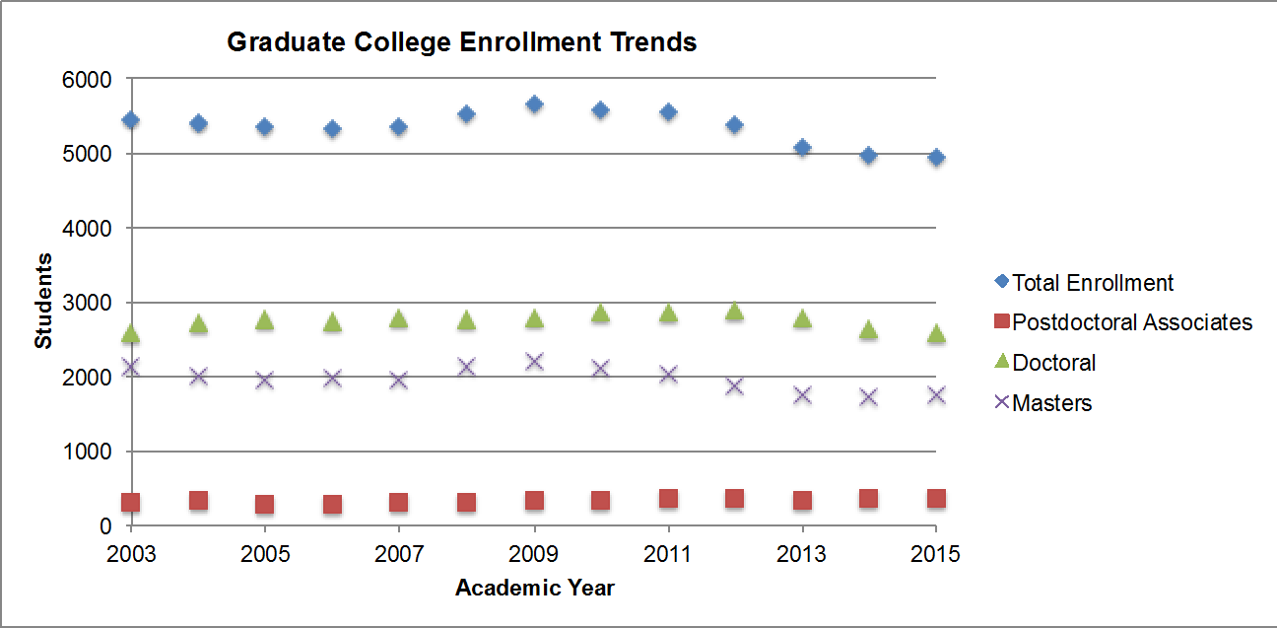

Figure C2. Graduate Underrepresented Minority Enrollments
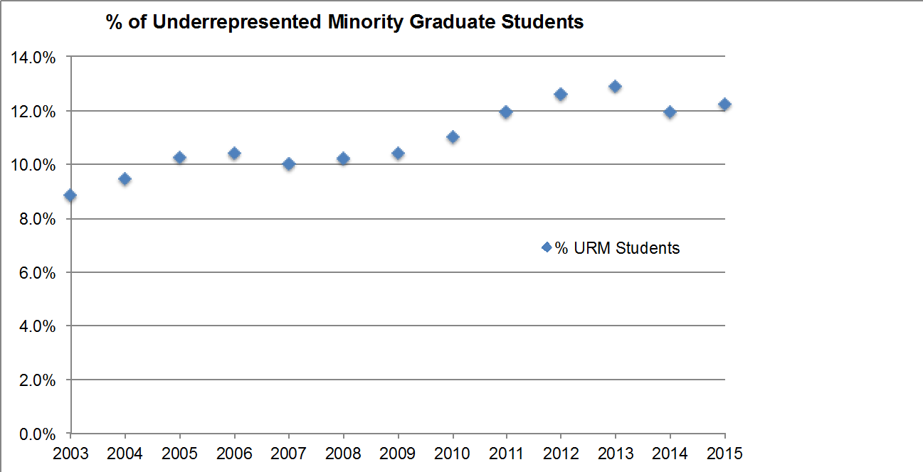

Notes: URM students = Alaskan Native or American Indian; African American or Black; Hispanic or Latino; Pacific Islander; % URM students= % (sum of URM students)/total domestic students

Figure C3. Enrollment by Curricular College

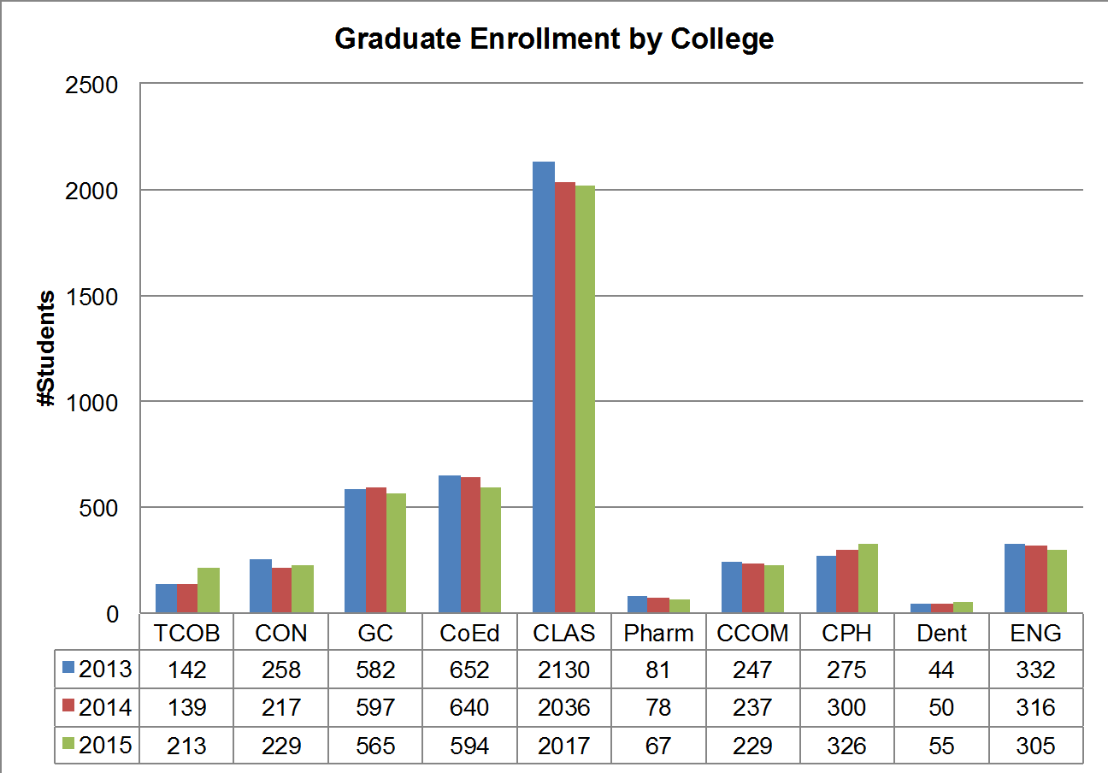

Figure C4. Graduate College General Education Fund Budget

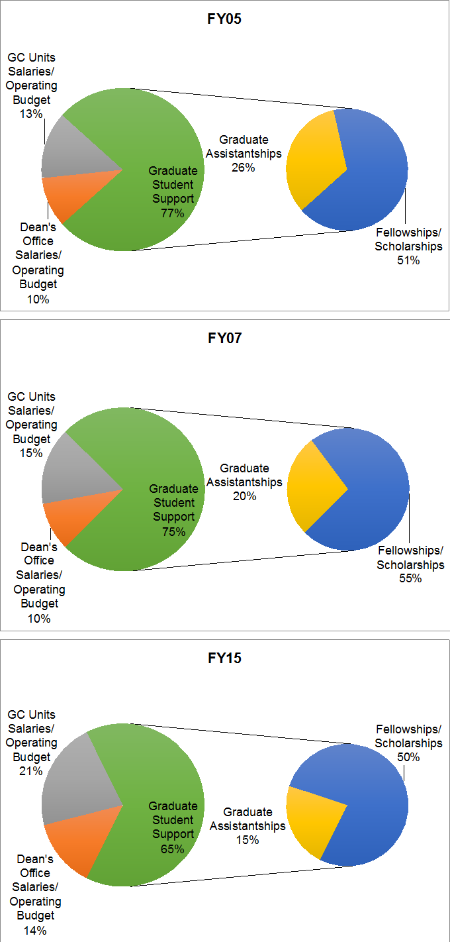

Notes: In FY07, the Graduate College started to administer the International Writer’s Program (IWP), the University of Iowa Press (UIP), The Center for the Book, and the Women in Science and Engineering (WISE) program. In FY10, the funding for the COGS tuition scholarships for all colleges was subtracted from the Graduate College GEF budget for comparison purposes since this was the only year shown here which included the tuition scholarships.

Figure C5. Graduate College External Funding

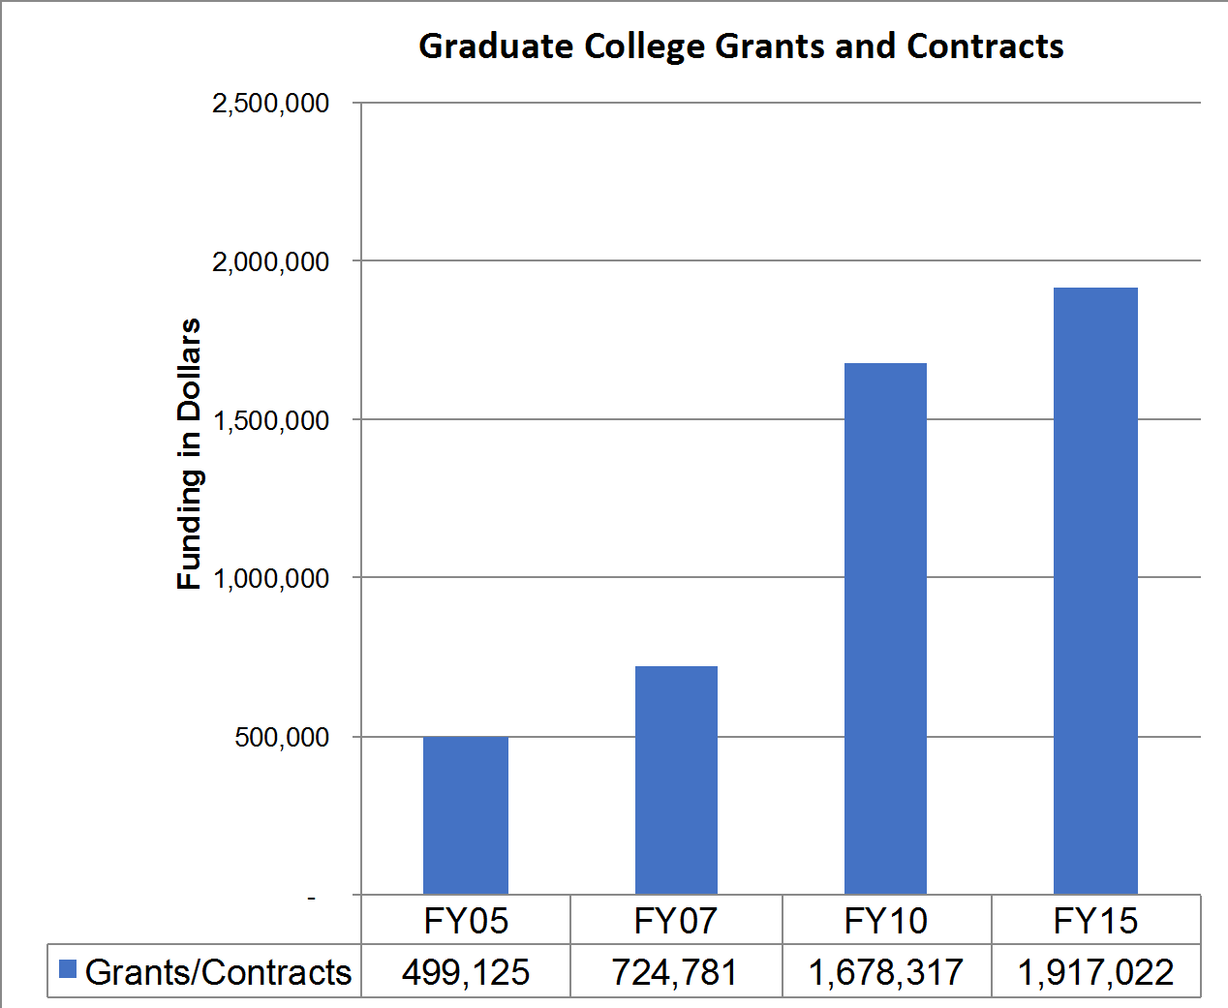

Notes: Grants and Contracts administered by the Graduate College. These are primarily grants and contracts obtained by the units and departments administered by the Graduate College.

Figure C6. Graduate College % Doctoral Completion & Time to Doctoral Degree (TTD)

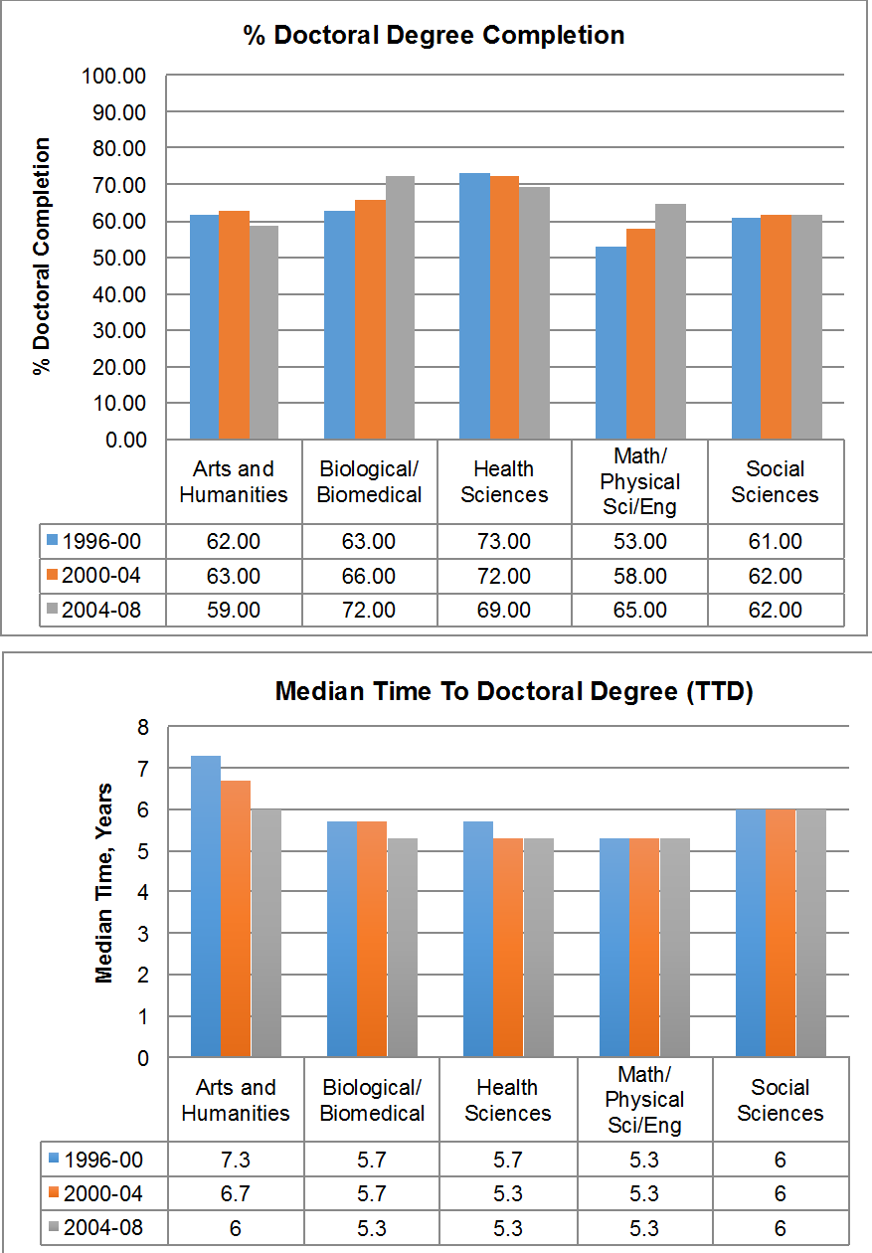

Notes: % Doctoral Completion and Time to Doctoral Degree (TTD) provided for graduate students in the 5 disciplinary subgroups who entered University of Iowa Graduate programs in the following time interval: 1999-2000, 2000-2004, 2004-2008.

Appendix D – Graduate College Review 2003-2004

REPORT OF THE GRADUATE COLLEGE REVIEW COMMITTEE

I. EXECUTIVE SUMMARY

The Graduate College Review Committee respectfully submits this report of our study of the Graduate College, its missions and goals, programs and procedures, and relations to other units within the University of Iowa. Throughout the report, we offer recommendations intended to facilitate future strategic planning on the part of the College. In this summary, we briefly inventory the main conclusions and recommendations that resulted from our study. Further details regarding these findings are contained within the report and its appendices.

We begin by noting that the Graduate College plays a critical role in the teaching, research, and service missions of the University of Iowa. The Review Committee is impressed by the College's careful and effective stewardship of graduate education and training. Since this is the first review of the College after its separation from the Office of the Vice President for Research in 1991, one question the Review Committee considered was whether continued independence from the Office of the Vice President for Research was optimal. In our judgment, graduate education warrants a dedicated college, whose primary mission is to act as an advocate for graduate education and to oversee graduate degree programs that Involve a reasonable level of research, scholarship, and creative work. Consequently, we find the current
organizational structure etTective. We note that the collaborative relationship between the two units is mutually beneficial and facilitated by the close proximity of the Graduate College to lhe
Office of the Vice President for Research. For this reason, one of our recommendations is that the units remain within close physical proximity.

Fu1thennore, we find that the Graduate College enjoys a unique perspective on emerging opportunities in research, scholarship, and creative work as a result of its oversight of trends in graduate education. Increasingly, these opportunities reflect interdisciplinary work, as evidenced by the growing number of interdisciplinary programs under the College's oversight. The Review Committee believes that the Graduate College's macro, centralized position in the University makes It an optimal location in which to house interdisciplinary programs. Yet, we believe that the University may not be taking full advantage of the College's position in this respect.

Clearly, the growing demands related to oversight of interdisciplinary programs coupled with stewardship over a diverse array of traditional non-interdisciplinary programs have become more challenging in the face of repeated budget cuts. Nonetheless, the College has continued to act as an important advocate for graduate programs and has even managed to develop new programs and initiatives in recent years. Despite its success, the Review Committee believes that the College's effectiveness may be at risk, as the demands placed on it begin to overcome resources. We believe that it is critical to provide the Graduate College with substantial additional resources to allow the College to capitalize on its unique visionary perspective, as well as to address rising pressures to enhance funding and programming for students. Our recommendations reflect the importance of providing full tuition scholarships for graduate assistants and expanding existing fellowship programs in order to compete for top students. The recommendations also reflect the need for additional staffing to allow the College to address

growing information technology needs and to capitalize on the rich data available about graduate education and trends in research, scholarship, and creative work. Current staffing levels do not adequately cover these needs and opportunities. At the same time, we do not believe that the Graduate College should be charged with overseeing post-doctoral programs, which are not directly related to graduate education, and we recommend that these programs be removed from the oversight of the Graduate College.

On a related note, we find that the Graduate College suffers from a lack of recognition within the University as well as the State of Iowa and believe that it is important for the College to increase its visibility. The College's success at securing resources depends, in part, on being recognized for its contributions to the overarching teaching, research, and service missions of the University. Toward the end of enhancing the College's visibility and the resources available to it, we recommend that the College consider appointing a development officer from the University of Iowa Foundation to facilitate fundraising efforts. Monies raised through the foundation may help address the need for additional resources that will allow the College to provide more funding to students in the form of tuition scholarships and fellowships and to act on strategic interdisciplinary opportunities when identified.

In addition, however, the Review Committee believes that College can more effectively administer a key existing resource, the block funds. A recurring theme in our study was dissatisfaction with the manner in which the block funds are currently allocaled. The focus of this dissatisfaction was on the lack of transparent criteria guiding the block allocation. We realize that the College is already studying the block fund allocations and recommend that, as this work continues, the College focus on defining the funds and the criteria guiding their allocation as a mechanism for enhancing graduate research, scholarship, and creative work. Additionally, we recognize the complexity of developing criteria for allocation procedures and assessing the effectiveness of the allocations made to particular programs, especially given the diverse graduate programs that the College oversees. We recommend that the College take care to develop flexible criteria that reckon, for instance, with the unique profile of students in fields for which professional experience prior to graduate studies is normative or required.

In summary, the Review Committee finds that the Graduate College is an effective and conscientious steward of graduate education. The deans and office staff are to be commended for their commitment to graduate education and vigor in meeting the growing demands placed on them. We believe that it is time for the University to invest further in a College that has yet to capitalize on its unique position. The observations and recommendations we offer in this report are intended to facilitate the strategic implementation of such investment.

2

Appendix E – Graduate Education Task Force; 2009-2010

Task Force on Graduate and Professional Education: Selective Excellence

Final Report February 12, 2010

Table of Contents

Executive Summary | 3
I. Introduction | 4
II. Assessment of Graduate Programs | 6
III. Categorization of Graduate Programs | 8
IV. Recommendations for Restructuring, Relocation and Possible Closure of Graduate Programs | 12
V. Additional Considerations Related to Achieving Excellence in Graduate Education | 17

Appendix A: List of Graduate and Professional Programs Administered by the Graduate College

Appendix B: Request for Strategic Assessments from Graduate and Professional Programs

Appendix C: Graduate College Data

Appendix D: Strategic Assessment Documents Submitted by Graduate and Professional Programs

Appendix E: Task Force Rating and Summary Rationale for Each Program

Appendix F: Reponses Submitted by Graduate and Professional Programs

Executive Summary

- Graduate programs at The University of Iowa administered by the Graduate College were evaluated by an interdisciplinary cross-collegiate Task Force through a process that involved examination of data, input from the individual programs and the Collegiate Deans, and open forums. Programs were grouped into five categories and the results are summarized below:
  - Exemplary (16 programs, 14.4%)
  - High Quality (46 programs, 41.4%)
  - Good (29 programs, 26.1 %)
  - Additional Evaluation Required (14 programs, 12.6 %)
  - Too New to Assess (6 programs, 5.4%)

- The Task Force made specific recommendations for additional evaluation of a number of graduate programs with issues requiring attention. These programs may become candidates for restructuring and/or closure. Further evaluation of these programs should include deliberations between the Collegiate Deans, the Graduate College Dean, the Provost and the individual departments.
- The Task Force made specific recommendations for restructuring of graduate programs. Restructuring was considered separately from the rating process because the Task Force felt that there were programs across all rating categories that could benefit from restructuring. In some cases restructuring was recommended for graduate programs that were not viewed as viable due to size or other factors and in other cases, restructuring was recommended based on redundancy and overlap in programmatic offerings. The Task Force recommends restructuring of graduate programs in several areas, including:
  - Languages and closely related disciplines
  - Health, sport and recreation disciplines
  - Biological science programs
Details of the restructuring are provided in the full report. The Task Force also recommended the relocation of several graduate programs to different colleges.

- The Task Force considered other issues related to improving the quality of graduate education at The University of Iowa. The Task Force makes the following recommendations for strategic investments:
  - Financial support- maintain competitive stipends and the tuition scholarship program; enable all graduate students to have both teaching and research assistantship experiences; prioritize Graduate College Fellowship and Strategic Investment Funds (SIF) programs to align with Task Force evaluations; increase private fundraising on behalf of graduate programs
  - Interdisciplinary graduate programs (IDGPs)- the majority of these programs should continue to report to the Graduate College and additional financial and administrative support should be provided to the Graduate College to serve this role.
  - Graduate recruitment and admissions- coordination and potential centralization of admission activities currently performed by the Office of Admissions, the Graduate College and individual programs.
  - Diversity- continued emphasis on diversity, focusing future efforts on recruitment, mentoring and retention.

- Introduction
The Task Force on Graduate Education: Selective Excellence was charged in April 2009 by Provost Loh. The charge and related issues that the Task Force may consider are listed below.

  - Charge
Articulate a strategic vision and priorities for increased excellence in graduate education at The University of Iowa.
Issues to address may include:
    - Based on the vision, the forthcoming NRC rankings, and other relevant criteria (quality, centrality, etc.), which areas—among the 100 or so graduate programs, including 70 doctoral programs—should get enhanced investment from new or reallocated resources, or be supported at the current level, or be downsized, or be phased-out?
    - What emerging opportunities in graduate education should the University pursue?
    - How can the recruitment, retention and time to degree of doctoral students and professional master’s students be improved?
    - How can graduate student support from all University sources be better coordinated?

  - Task Force Members
The Task Force was assembled with broad-based representation from UI colleges and Graduate College disciplinary groups (Arts and Humanities; Social Sciences; Physical Sciences and Engineering; Health Sciences; and Biological Sciences). There were at least three members from each disciplinary group and there was a graduate student representative as well. The Task Force members and their home departments are listed below.
Chair: Sarah Larsen, Professor, Chemistry
Tim Ansley, Associate Professor, Psychological & Quantitative Foundations
Kurt Anstreicher, Professor, Management Sciences Gail Bishop, Professor, Microbiology and Immunology Tom Boggess, Professor, Physics & Astronomy
Sandra Damico, Dean, College of Education Maureen Donovan, Professor, Pharmaceutics Bernd Fritzsch, Professor, Biology
Keri Hornbuckle, Professor, Civil & Environmental Engineering
Michael Jones, Professor, Biostatistics
Tom Lewis, Professor, Spanish & Portuguese
Ann Marie McCarthy, Professor, Nursing

Cathleen Moore, Professor, Psychology
Alexandra Nica, Graduate Student, Economics
Andrew Russo, Professor, Molecular Physiology and Biophysics
John Beldon Scott, Professor, Art & Art History Alberto Segre, Professor, Computer Science Claire Sponsler, Professor, English
Marc Wold, Professor, Biochemistry
Ex officio: John Keller, Associate Provost for Graduate Education
Ex officio: Don Szeszycki, Associate Vice President, Office of the Provost

  - Timeline and Overview of Process
The Task Force held a series of meetings in spring 2009 to discuss the assessment process that would be implemented to evaluate the graduate programs. The charge was defined to include all graduate and professional programs administered by the Graduate College. The Task Force decided to seek input from the individual graduate and professional programs, from the Collegiate Deans and from the University community through Open Forums. The Task Force developed a strategic assessment document to be completed by each program being evaluated (Appendix A). The strategic assessment is a brief, narrative self-study covering three critical areas related to graduate and/or professional education within a specific program: Admissions Processes and Criteria, Program Outcomes, Program Characteristics. A complete copy of the request for strategic assessments is included in Appendix B. The request along with data from the Graduate College (Appendix C) was sent to graduate and professional programs in June 2009 with a due date of September 15, 2009. The completed strategic assessment documents (Appendix D) were submitted to the Task Force and were also provided to the Collegiate Deans. The Task Force met with the Collegiate Deans to discuss the programs within their colleges. The Task Force discussed each of the programs, and using the taxonomy described in Section II, the Task Force categorized each of the programs. Draft documents including the program rating and a brief summary rationale were provided to each graduate program and to the Collegiate Deans in early January 2010. The programs were given the opportunity to respond to the draft documents. All program responses were reviewed by the Task Force and final ratings and rationales (Appendix E) and program responses (Appendix F) are included in this report.

  - General Observations and Comments
Overall, graduate programs at Iowa are doing a very good job of producing well-trained scholars (and in some cases professionals) and meeting the educational needs of Iowa and beyond. There are over 100 graduate programs administered by the Graduate College in 5 disciplinary groupings: i) Arts and Humanities; ii) Social Sciences; iii) Mathematical, Physical Sciences and Engineering; iv) Health Sciences; and v) Biological Sciences. The Task Force has the following comments regarding graduate education and the rating process.
    - The Task Force evaluated graduate and professional programs administered by the Graduate College. The Task Force did not evaluate graduate or professional programs administered by other colleges (i.e., JD, MD, DDS, PharmD, MBA, MPA). The Task Force did not evaluate departments, faculty scholarship or teaching, or undergraduate programs. There are examples in which strong academic

departments have issues related to the management of graduate education that need attention and these graduate programs may not be as highly rated for this reason. For example, a very low doctoral student completion rate or a very long time to degree (TTD) in an otherwise strong department resulted in a lower than expected rating for some programs. There are also graduate programs that the Task Force categorized as a candidate for possible reorganization or closure while recognizing that the department has a viable or popular undergraduate major.
    - The new National Research Council (NRC) rankings of graduate programs are not yet available. If programs included other rankings in their strategic assessments the Task Force considered this information. However, in rating programs, the Task Force weighted student-based indicators (outcomes such as % completion, time to degree and placement) more heavily than overall department reputation or productivity.
    - In order to evaluate programs consistently, using data available for all programs, the Task Force used the doctoral median TTD and doctoral completion rate data for entering doctoral students for the 5 year period from 1996-2001. The Task Force also considered the retrospective median TTD data for PhD’s awarded during the time period 2003-2008. The Graduate College data is provided in Appendix C. The University of Iowa Graduate College computes the median TTD of all PhD graduates as the median time it takes for graduate students to earn their Ph.D. at Iowa. Previous graduate work at another institution is not taken into consideration since it was felt that the program has no control over that previous work. Thus, the UI reported median TTD is almost always lower than those reported nationally which typically include all graduate work.
    - The Task Force’s objective was to rate programs consistently across the 5 disciplinary groups, recognizing that there are a wide range of programs, missions and disciplinary norms. For example, there are graduate programs with more professional versus research-oriented missions and there are master’s versus doctoral programs.
    - The Task Force rated programs as objectively as possible based on the programs’ strategic assessment and on available data. The Task Force would like to note that these ratings represent a snapshot in time and do not reflect any temporal component or trajectory for the programs.
    - The University of Iowa is smaller than our peer CIC institutions. Most of our departments have fewer faculty than similar departments at our peer institutions. As far as size can often be equated with quality, there are many programs that can argue that if given resources to grow they would be more competitive with peers. Many graduate programs at UI are better than would be predicted based on their size as reflected by numbers of faculty and graduate students. Given the constraints related to program growth, continued excellence in graduate education at UI will require strategic focus and enhanced collaboration at curricular, programmatic, and collegiate levels.
    - The current distribution of graduate programs at The University of Iowa has evolved over time and in some cases is not optimal. Some reorganization of graduate programs may increase efficiency while continuing to meet the educational needs of the University and the state of Iowa. It is important for related disciplines to work together.

- Assessment of Graduate Programs
The Task Force conducted an evaluation of the graduate programs as described below and placed each program into one of five categories: Exemplary, High Quality, Good, Additional Evaluation Required, and Too New to Assess. Program evaluations were based on:
  - Information on all programs provided by the Graduate College which included size of the program, number of fall applicants and enrollment (selectivity and yield); average GRE scores and GPAs; Graduate College fellowships awarded; and completion, time to degree, and placement of doctoral students for specified time periods. (Appendix C)
  - Strategic assessments provided by each graduate program (Appendix D) that included information on:
    - Mission of the program
    - Admission processes and criteria, including recruitment, selectivity, diversity and financial support
    - Program outcomes, including degree completion, time to degree, fellowships, awards, honors, publications, and placements of graduate students
    - Program characteristics, including program size, comparison with other programs such as national rankings, centrality to the University, and perceived strengths, weaknesses, opportunities, threats of the program and plans for the program’s future.

  - Discussion with Deans from each college
Based on these evaluations, each program was rated and placed into one of the following categories:

Exemplary: These programs stand out in terms of their overall quality and capacity to provide national/international prestige to The University of Iowa. Programs may be exemplary in different ways, depending upon their mission. Exemplary programs are generally rated highly in all areas.

High Quality: These programs are strong and have the potential to enhance the national reputation of The University of Iowa. These programs rate very well in most areas, but improvements could be made to strengthen the programs. In areas in which these programs are not as highly rated, plans should be created (if not already in place) to demonstrate improvement.

Good: These programs are doing well, but have issues that preclude a higher ranking. Clear plans for improving areas of relative weakness should be created (if not already in place) that will solidify the program’s reputation.

Additional Evaluation Required: These programs have significant problems related to two or more of the following without viable plans for improvement in the problem areas:
    - Incongruent mission, size and/or structure
    - Admission processes and criteria, such as recruitment, selectivity, diversity and financial support
    - Program outcomes, such as degree completion, time to degree, fellowships, awards, honors, publications, and placements
    - Program characteristics, such as program size, comparison with other programs, centrality to the University, and plans for the program’s future.
Some programs may be candidates for restructuring and/or merging with other related programs. Some programs in this category may become candidates for closure. Further evaluation of programs in this category should occur in consultation with the Collegiate Deans, the Graduate College Dean, the Provost and the program faculty.
Too New to Assess: These programs are either too new (< 5 yrs) to have significant student outcomes, or have recently undergone significant transitions that require time for the program to develop.

- Categorization of Graduate Programs
Following the assessment process described above and TF discussions, the graduate programs were categorized as: Exemplary (14.4%; 16/111), High Quality (41.4%; 46/111), Good (26.1%; 29/111), Additional Evaluation Required (12.6%; 14/111), Too New to Assess (5.4%; 6/111). The graduate programs in each category are listed in the tables below by disciplinary group. Summaries with the rationale for the rating were prepared for each program by the Task Force. The summaries are provided in Appendix E.

Exemplary (14.4%; 16/111)

Arts and Humanities | Social Sciences | Mathematical, Physical Sciences, Engineering | Health Sciences | Biological Sciences
Communication Studies M.A., Ph.D. | Psychology M.A., Ph.D. | Actuarial Science M.S. | Biostatistics M.S., Ph.D. | Immunology Ph.D.
Creative Writing M.F.A. | CRSD: Rehabilitation Counselor Education Ph.D. | Civil and Environmental Engineering M.S., Ph.D. | Nursing M.S.N. | Neuroscience Ph.D.
English M.A., M.F.A., Ph.D. | CRSD: Community/ Rehabilitation Counseling M.A. |  | Pharmacy M.S., Ph.D. | Speech and Hearing Science Ph.D.
 | Psych/Quant: Educational Measurement and Statistics M.A., Ph.D. |  | Physical Therapy D.P.T.

High Quality (41.4%; 46/111)

Arts and Humanities | Social Sciences | Mathematical, Physical Sciences, Engineering | Health Sciences | Biological Sciences
Art History M.A., Ph.D. | Accounting M.Ac., Ph.D. | Biomedical Engineering M.S., Ph.D. | Dental Public Health M.S. | Biochemistry M.S., Ph.D.
Art M.A., M.F.A. | CRSD: Counselor Education and Supervision Ph.D. | Chemical and Biochemical Engineering M.S., Ph.D. | Epidemiology M.S., Ph.D. | Free Radical and Radiation Biology M.S., Ph.D.
Classics M.A., Ph.D. | CRSD: School Counseling M.A. | Chemistry M.S., Ph.D. | Health Management and Policy M.H.A. | Genetics Ph.D.
Library and Information Science M.A. | CRSD: Student Affairs Admin and Research Ph.D. | Computer Science MCS, M.S., Ph.D. | Health Services and Policy Ph.D. | Microbiology M.S., Ph.D.
Spanish and Portuguese, M.A., Ph.D. | CRSD: Student Development in Postsecondary Education M.A. | Mathematics M.S., Ph.D. | Nursing Ph.D. | Molecular and Cellular Biology Ph.D.
Theatre Arts M.F.A. | Economics M.A., Ph.D. | Mechanical Engineering M.S., Ph.D. | Occupational and Environmental Health M.S., Ph.D. | Pharmacology M.S., Ph.D.
 | EPLS: Higher Education, M.A., Ph.D. |  | Oral Science M.S., Ph.D. | Speech Pathology and Audiology M.A.
 | Geography M.A., Ph.D. |  | Orthodontics M.S.
 | Management and Organizations Ph.D. |  | Pathology M.S.
 | Psych/Quant: Counseling Psychology Ph.D. |  | Physical Rehabilitation Science Ph.D.

 | Psych/Quant: School Psychology Ed.S., Ph.D. |  | Master of Public Health (MPH)
 | Second Language Acquisition Ph.D.
 | Social Work M.S.W
 | Sociology M.A., Ph.D.
 | Teaching and Learning: Science Education M.S., MAT, Ph.D.
 | Urban and Regional Planning M.A., M.S.

Good (26.1%; 29/111)

Arts and Humanities | Social Sciences | Mathematical, Physical Sciences, Engineering | Health Sciences | Biological Sciences
Dance M.F.A. | Anthropology M.A., Ph.D. | Applied Math and Computational Science Ph.D. | Operative Dentistry M.S. | Anatomy and Cell Biology M.S., Ph.D.
Film and Video Production M.F.A. | Finance Ph.D. | Geoscience M.S., Ph.D. |  | Biology M.S., Ph.D.
French and Francophone World Studies M.A., Ph.D. | Leisure Studies M.A. | Electrical and Computer Engineering M.S., Ph.D. |  | Molecular Physiology and Biophysics M.S., Ph.D.
History M.A., Ph.D. | Management Science Ph.D. | Industrial Engineering M.S., Ph.D.
Journalism M.A. | Marketing Ph.D. | Physics M.S., Ph.D.; Astronomy M.S.
Mass Communications Ph.D. | Political Science M.A., Ph.D. | Statistics M.S., Ph.D.
Music M.A., M.F.A., D.M.A., Ph.D. | Psych/Quant: Educational Psychology M.A., Ph.D.
Philosophy M.A., Ph.D. | Social Work, Ph.D.
Religious Studies M.A., Ph.D. | Teaching and Learning: Secondary Education M.A., MAT, Ph.D.
 | Teaching and Learning: Special Education M.A., Ph.D.

Additional Evaluation Required (12.6%; 14/111)

Arts and Humanities | Social Sciences | Mathematical, Physical Sciences, Engineering | Health Sciences | Biological Sciences
American Studies M.A., Ph.D. | EPLS: Educational Administration M.A., Ed.S., Ph.D. |  | Stomatology M.S. | Integrative Physiology Ph.D.
Asian Civilizations M.A. | EPLS: Social Foundations of Education M.A., Ph.D. |  |  | Exercise Science M.S.
Comparative Literature M.A., Ph.D. | Health and Sport Studies M.A., Ph.D.
Comparative Literature--Translation M.F.A. | Teach and Learn: Elementary Education M.A., Ph.D.
Film Studies M.A., Ph.D.
German M.A., Ph.D.
Linguistics M.A., Ph.D.

Too New to Assess (5.4%; 6/111)

Arts and Humanities | Social Sciences | Mathematical, Physical Sciences, Engineering | Health Sciences | Biological Sciences
 |  |  | Community and Behavioral Health M.S., Ph.D. | Human Toxicology M.S., Ph.D.
 |  |  | Nursing DNP | Informatics M.S., Ph.D.
 |  |  | Translational Biomedicine, Ph.D. | Speech Pathology and Audiology Au.D.

- Recommendations for Restructuring, Relocation and Possible Closure of Graduate Programs
  - Background
Along with its assessments of current graduate program offerings, the Task Force noted a number of possible situations in which a re-envisioning of graduate program offerings may be beneficial to The University of Iowa. This includes graduate programs which may not be viable in their current configuration and strong programs that the Task Force feels would be strengthened by a restructuring. The Task Force noted that many programs assessed to be “Exemplary” or “High Quality” demonstrated substantial formal and informal interconnections across a variety of campus units, including departments, colleges, and centers. While many traditional disciplines remain relevant, other possibilities emerge which have the potential to strengthen and improve graduate program offerings at The University of Iowa. These possibilities include:
    - restructuring graduate programs into logical programmatic “clusters”;
    - enhanced intellectual synergies through “clustering of curricular offerings” and research and scholarly effort;
    - administrative re-location of graduate programs in order to create administrative synergies with other collegiate units; and
    - in a few cases, identification of a graduate program as a candidate for closure.

These recommendations are in sync with national trends that tend to offer more integrated, cohesive graduate programs by drawing on interdisciplinary and multidisciplinary approaches to address disciplinary questions and key issues that challenge our society in the twenty-first century.^{1,2} For many small graduate units that remain relevant, but struggle to draw student interest, enhanced collaboration is key to bringing selected graduate programs together to provide relevance and viability for the future. Merging with other like units may present opportunities for:
    - intellectual communities offering more collective courses, seminars and research opportunities;
    - enhanced academic and scholarly engagement for faculty and students;
    - an evolution of new and timely graduate programs.

  - Restructuring of Graduate Programs in the Languages and Closely Related Disciplines
The University of Iowa offers a number of advanced degrees in languages and related disciplines. MA and PhD degrees are offered in the following CLAS departments: French and Francophone World Studies, German, Spanish and Portuguese, and Linguistics. A PhD in Second Language Acquisition is offered through an interdisciplinary graduate program administered by the Graduate College but sponsored by FLARE (Foreign Language Acquisition and Research), which is located in International Programs. Master’s degrees are offered in Asian Civilizations (MA) and Comparative Literature-Translation (MFA).
Within the grouping of language programs and closely related disciplines there are several programs that the Task Force felt required additional evaluation: Asian Civilizations, Comparative Literature-Translation, German, and Linguistics. In Fall 2009, admission to the German PhD program was suspended due to low enrollments and declining faculty numbers. Asian Civilizations, which offers an MA degree focused on Chinese Studies and Japanese Studies, has stopped admitting master’s students planning to study

¹ Council of Graduate Schools, Communicator, Vol. 42(7), Aug-Sept. 2009
² Inside Higher Ed, May 2009

Japanese due to faculty losses. The viability of these programs is in jeopardy in part due to declining numbers of students and faculty.

The formation of a division of languages and cultures has been discussed by language departments located in Phillips Hall. The Task Force supports the proposed restructuring of these departments and feels that there are many potential advantages for the graduate programs. The proposed merging of the administrative structures of these departments could provide opportunities for graduate programs with declining disciplinary graduate prospects to work with a larger pool of graduate students. The proposed division could also lead to synergistic research collaborations between faculty in the languages and in other closely related disciplines. These graduate programs may also benefit from the increase in critical mass resulting from larger student and faculty cohorts.

The Task Force also recommends that the Second Language Acquisition (SLA) Ph.D. program be relocated to CLAS as part of the proposed division (section III.G.). The SLA doctoral program has flourished in the Graduate College and while the Task Force recognizes that this program is unique in its position as an interdisciplinary program, the Task Force feels that this program could be an important part of the proposed division. If the proposed division is not formed, further evaluation of whether SLA should be relocated will be required.

  - Restructuring of Graduate Programs in Health, Sport and Recreation Disciplines
CLAS has several graduate programs in the broadly defined area of health, sport and recreation. Graduate degrees are offered in Exercise Science (MS), Leisure Studies (MA), Health and Sport Studies (MA, PhD) and Integrative Physiology (PhD). In the strategic assessment and response submitted by Integrative Physiology, an Integrated Health Sciences formed by combining Integrative Physiology, Leisure Studies, and part of Health and Sport Studies was discussed. The Task Force supports restructuring these programs. However, the Task Force has concerns related to the impression given by the proposed name of Integrated Health Science. It was felt that this name at a university with a large health science complex typically suggests an affiliation with traditional health science colleges such as pharmacy, medicine, nursing and dentistry. Furthermore, while the Task Force recognizes the overlap between the Exercise Science MS and the Leisure Studies MA, the Task Force felt that more natural intellectual overlap would occur for the doctoral program in Integrative Physiology with the doctoral programs in Physical Therapy and Rehabilitation Science, Anatomy and Cell Biology (anatomy/gross anatomy component), Biomedical Engineering and potentially other programs in several health science colleges. The Task Force feels that the Department of Integrative Physiology should consider options for building the graduate program through increased interactions with one or more of these programs. Health and Sport Studies, a largely social sciences program, has also been suggested in the proposed administrative restructuring of these disciplines. The Task Force does not see a compelling intellectual overlap between Health and Sport Studies and the Integrative Physiology doctoral program, but potential synergies of Health and Sport Studies with Leisure Studies and Exercise Science should be explored.

  - Proposed Restructuring of Biological Science Graduate Programs
Currently, The University of Iowa offers fourteen doctoral programs categorized in the biomedical and life sciences disciplines. Department-based programs are located in the CCOM (6) and CLAS (3) while the interdisciplinary graduate degree programs are located administratively in the Graduate College (5). While providing a broad spectrum of program offerings, the ability of the programs to recruit students, provide cogent, synergistic curriculum and a clear administrative structure is often viewed as confusing and inefficient. Over the past few years, improvements have been made to recruitment and curricular issues to offer a collaborative approach to recruiting and educating doctoral students. However, the breadth of program offerings remains confusing to students and faculty alike, a fact that is exacerbated by the involvement of many faculty in multiple interdisciplinary as well as departmental programs. The Task Force recommends restructuring of these programs to address current and future needs. The Task Force makes its recommendations based on:
- assessments of program quality including size of the programs, student characteristics, TTD, % completion, centrality, etc;
- the program narratives and mission statements (in which the Task Force recognizes many similarities and redundancies in the current biomedical programs), and;
- the extent of participation by departmentally-based faculty in the interdisciplinary programs.

Although their faculty participate in the interdisciplinary programs, significant components of departmentally-based graduate programs such as Biochemistry, Microbiology, and Speech and Hearing Science as well as the interdisciplinary programs in Neuroscience, Genetics and Immunology are more distinctive in their mission and research foci. Human Toxicology was determined to be too new to assess, while the Task Force makes a specific recommendation (see IV.C.) to address Integrative Physiology.

The graduate program in Biology poses a significant challenge at The University of Iowa. This program is located in CLAS, is geographically separate from the majority of other bioscience programs and has a very different teaching environment with faculty who are both involved in departmental and interdisciplinary programs. The Biology program offers four formal subtracks (Cell and Developmental Biology, Genetics, Neurobiology, and Evolution) that are used in both graduate and undergraduate teaching, three of which overlap by name with interdisciplinary graduate programs. The fourth, Evolution, is unique to Biology. The majority of the departmental faculty are active members in several of the interdisciplinary programs. Biology faces further challenges by having to compete for students with the other bioscience programs via the Biosciences admissions portal and by having a large undergraduate major and service teaching load. Biology also has a large number of graduate teaching assistantships that are not available to the other bioscience programs and are needed to maintain the undergraduate teaching as is the case for other science graduate programs in CLAS such as Physics, Chemistry, etc.
The Task Force recommends a reorganization of the bioscience graduate programs focusing on the programs with the most overlap. As one option, the Task Force suggests that current programs in Biology, Biochemistry, Microbiology, Speech and Hearing Science, Neuroscience, Genetics, and Immunology, be maintained, while departmentally-based programs such as Molecular Physiology and Biophysics, Anatomy and Cellular Biology, Pharmacology and Free Radical and Radiation Biology and the interdisciplinary Molecular and Cellular Biology be merged or reorganized. This reorganization could include faculty in these programs joining other programs with appropriate overlapping interests or the creation of a new broader interdisciplinary program with an appropriate subtrack structure offering flexibility in defining areas of interest (e.g., cancer biology or molecular medicine). The Task Force also notes that the current Molecular and Cellular Biology program has substantial overlap with the other programs (many of the

faculty in the programs already are members of the MCB program) and could serve as the foundation for a broader based interdisciplinary program.

  - Restructuring of Other Graduate Programs
The Task Force recommends that graduate programs in other areas could also be strengthened through connections with related disciplines. For example, communication-related disciplines should explore the option of combining graduate programs including: Mass Communications (PhD); Journalism (MA); Communication Studies (MA, PhD). The intellectual overlap between these programs may lead to fruitful collaborative efforts that could enhance graduate education in these areas. The merger of the Stomatology MS into the Oral Science (MS, PhD) program is also recommended.

Restructuring of graduate programs could also alleviate stresses associated with budget reductions that have resulted in an increase in the minimum enrollment required for graduate courses in CLAS, for example. Assuming the lack of resources available in the near future for things like faculty hiring, some programs may have issues with viability in the near term if restructuring does not occur. For example, a doctoral graduate program size of 25 implies 5 new students per year (assuming a TTD of 5 years) which may be below new minimum course enrollments being implemented due to budget reductions. This will inevitably lead to difficulties with delivering a rigorous graduate curriculum and maintaining small graduate program viability. Programs vulnerable to this scenario should think proactively regarding restructuring. Some of the challenges to this reorganization are location and space. If two units are located in different buildings or on different parts of campus, building connections between programs will be more difficult. In these cases, the Task Force recommends investment in the infrastructure required to accomplish the proposed reorganizations.
  - The Task Force carefully considered and makes the recommendations to relocate the following graduate programs
- Second Language Acquisition (SLA) from the Graduate College to the proposed division of world languages and cultures that is under consideration in the College of Liberal Arts and Sciences. A number of the current language programs are suffering from declining numbers of faculty, declining interest in selected graduate programs and pressure to economize the administration of small language units into a cohesive unit. Several language programs were assessed as needing restructuring/merger and in some cases closure of the doctoral programs. The SLA program, on the other hand, is thriving, with high-quality student interest, and strong faculty support. Although SLA was originally approved as an interdisciplinary program administered in the Graduate College, most, but not all faculty are from CLAS (others are appointed in the College of Education), and a significant number of graduate (teaching) assistantships are provided by CLAS units. The Task Force recognizes that some of the unique aspects of SLA as an interdisciplinary program could be lost in such a merger but feels that the potential benefit to the proposed division is compelling.

- Applied Mathematical and Computational Sciences (AMCS) from the Graduate College to the College of Liberal Arts and Sciences. Since its original approval, AMCS has been closely integrated with the graduate program in Mathematics. AMCS and Math provided one narrative in response to the Task Force’s request, thus it has been assumed by the Task Force that the programs themselves see AMCS as part of

Math. Math provides administrative support for AMCS, as well as graduate (teaching) assistantships. Many, but not all faculty affiliated with the program are from Math. Other affiliated faculty are appointed in related physical science programs across campus. Many students matriculate into AMCS from Math, while others are direct admits.
- Economics from the Tippie College of Business to the College of Liberal Arts and Sciences. This possibility has apparently been discussed prior to the work of the Task Force. At most peer institutions, Economics is located in Liberal Arts colleges as a central social science unit. The Task Force sees Economics as central to the UI’s mission, however it is not certain as to the level of priority it receives in the TCOB. There have been a number of lost FTE faculty positions over the past few years. Economics appears to provide considerable undergraduate instruction to majors and as service courses to undergraduate students in CLAS. Previous discussions about such a relocation apparently identified serious obstacles to such a move; however, the Task Force determined that if Economics is to thrive at the UI, relocation to CLAS or re-investment in the program by TCOB should be seriously considered.

  - Suggestions for Administering Reorganized Graduate Programs
In an era requiring more accountability and data sharing, it is imperative for the Graduate College to be able to adequately track graduate student progress. Restructuring of graduate programs could create administrative challenges that will require coordinating efforts between programs, departments, colleges, the Graduate College, and the university’s admissions and registrar’s offices to ensure that degree majors and subtracks that might be created are organized consistently in order to facilitate data reporting on graduate students. The Task Force recommends that concurrent with program restructuring, degree majors and subtracks be formed consistently and in collaboration with the Graduate College and the Registrar to facilitate data tracking. Although a tracking problem was most apparent to the Task Force within programs in the College of Education, other graduate programs with subtracks (e.g., Civil and Environmental Engineering) would benefit from the ability to track students from the time of admission by an appropriately coded subtrack in order to facilitate data reporting.

  - Emerging Opportunities in Graduate Education
Even in this climate of budget reductions and programmatic shrinkage, it is imperative to consider emerging opportunities in graduate education to build on existing strengths and develop new areas of academic excellence.
The Task Force would like to note the Spanish Creative Writing MFA proposed by the Department of Spanish and Portuguese that would train members of new generations of writers in Spanish. At present only one such MFA program exists in the U.S., and only a handful of U.S. colleges and universities offer any course at all in Spanish creative writing. The proposed MFA would build on the UI’s superior reputation in creative writing through the Iowa Writers’ Workshop (IWW) and the International Writing Program (IWP), both of which would offer experience and infrastructure to the proposed Spanish Creative Writing MFA program. The Department of Spanish and Portuguese has a long-standing tradition of support for creative work.

The Center for the Book has proposed a new MFA in Book Studies which takes advantage of the unique strengths available at The University of Iowa. Drawing students from several humanities disciplines, the new MFA will train its graduates for academic careers in book arts, as well as for professional careers in book trades and in libraries and studios. The Graduate Council has approved the proposal which awaits completion of the formal approval process.
There are several new programs which, although rated as “Too new to assess,” seem to be well-positioned for the future. It should be noted that two of these are interdisciplinary degree programs administered by the Graduate College (Human Toxicology and Informatics), two are new degree programs from departments that already have exemplary programs (Nursing DNP and Speech Pathology and Audiology AuD) and one is located in the College of Public Health (Community and Behavioral Health). The graduate program in Translational Biomedicine, with its affiliation in the Health Sciences Center and the Clinical and Translational Science Awards (CTSA) program, is also viewed as beneficial to the long-term success and reputation of the University.

- Additional Considerations Related to Achieving Excellence in Graduate Education
In addition to assessing the graduate program offerings at The University of Iowa, the Task Force on Graduate Education considered a number of important issues pertinent to the delivery of graduate programs at the University. The Task Force has determined that these issues need attention in order for graduate programs and graduate education in general, to reach their full potential.

  - Financial Support for Graduate Students and Programs
The Task Force is concerned with the declining support for graduate assistantships as a result of recent budget reductions. Many colleges have been faced with reducing teaching assistantship (TA) lines and the Graduate College has been forced to reduce its support of research assistantship (RA) positions to meet budget reversions. Continued losses in these areas, if not coordinated with the recommendations of this Task Force, as well as that of the Research and Undergraduate Task Forces, will have serious implications for graduate education at Iowa.
The topic of insufficient and in some cases, declining financial support for graduate students and programs was pervasive throughout the self-assessments submitted by programs. The Task Force recognizes that through negotiations with COGS (the UI’s graduate employee union) substantial progress has been made to offer competitive compensation packages, including stipends, benefits and tuition scholarships. As indicated in the most recent “Purdue Report” (click), Iowa ranked third and fourth, respectively in the average net compensation offered to Teaching and Research Assistants. The Task Force strongly recommends that The University of Iowa continue to maintain its competitive stature amongst its Committee on Institutional Cooperation (CIC) peers through stipends and the tuition scholarship program.

Nonetheless, considering the number of highly rated programs ( ~56% assessed as Exemplary or High Quality), additional support and a restructuring of current support mechanisms are recommended, in order to adequately support these programs as well as provide incentives for improvements to other programs (Good, Too New to Assess).
Graduate Assistantships: A number of recent reports, including the Council of Graduate Schools’ report

on PhD Completion and Attrition³, advocate for a blend of dedicated funding mechanisms for doctoral students for a specific number of years, to include fellowships and teaching and research assistantships. funding mechanisms for doctoral students, including fellowships, and teaching/research assistantships. Many graduate programs at UI are dependent upon graduate TAs as the main mechanism of support for their students. The Task Force recognizes the importance of the synergistic relationship between many graduate programs and the complementary undergraduate programs. We recommend that, where appropriate, such affiliations be promoted for the intellectual, educational, and career benefits of graduate students, undergraduates, and faculty. The Task Force recognizes the value of teaching opportunities as a component of graduate student training and encourages programs with strong research support to also consider including formalized teaching assistantships for graduate students funded from research.

Limiting graduate support to solely TAs may impede student progress towards their degree leading to a longer time to degree, and in some cases may not be the most appropriate vehicle to deliver undergraduate instruction. The Task Force recommends that the model for graduate student support for all programs include several years of non-TA support for graduate students. This might require that the number of TA positions be reduced in selected areas, and then a portion of the released funds could be redeployed to provide competitive fellowships and assistantship positions through the Graduate College’s Fellowship programs and the Strategic Initiative Fund (SIF) program.

Fellowships/SIF: Concurrently, the Graduate College is encouraged to revise its Fellowship and SIF programs with the goal of promoting and maintaining excellence through support of exemplary and high quality programs and building excellence in good and too new to assess programs. The Task Force encourages the Graduate College to prioritize Fellowship opportunities for students in programs rated as Exemplary and High Quality followed by those in Good and Too New to Assess. The Task Force also recommends that the Graduate College reserve a portion of the SIF for investing in programs that are on upward trajectories but with ratings that do not yet reflect the program improvements that are being implemented. The Task Force feels that some enhanced SIF investments could yield high returns for the Graduate College and for the University.
Programs are encouraged to hold annual seminars for their students with the staff from the Graduate and Professional Student Resource Office, sponsored by the Graduate College and Sponsored Programs, for expert assistance in seeking external funding to support research, dissertation, travel, and other scholarly activities. Program websites could also include links to funding resources.
Considering the strengths and national prominence of many graduate programs at the University, the Task Force strongly recommends that private fundraising on behalf of graduate programs and graduate education become a high priority for University fundraising efforts. As is occurring at other peer institutions, new collaborations between departments, colleges, and the Graduate College with the UI Foundation should be explored to address the challenges of seeking support for graduate education.

³ Ph.D. Completion and Attrition: Policy, Numbers, Leadership, and Next Steps. Council of Graduate Schools, Washington, D.C., 2004.

  - Administrative Organization and Oversight of Interdisciplinary Graduate Degree Programs
The Task Force recognizes the importance and value of the interdisciplinary graduate degree programs (IDGPs) at The University of Iowa. A number of these programs are assessed as “Exemplary” or “High Quality” and bring prestige and recognition to the University. Historically at Iowa, IDGPs have arisen from the “grass-roots” level, when faculty from a breadth of units across campus come together to organize and deliver a non-departmental or collegiate-structured graduate program. Some IDGPs at Iowa have been in place for over 25-30 years, while others are more recent. Over time, the Graduate College has become the administrative home for these programs, providing financial support in the form of graduate assistantships, and in some cases staff and program support.
The IDGPs face a number of challenges, many of which are similar to other “interdisciplinary” activities on campus:
    - Many of the participating faculty essentially volunteer their time and effort to the IDGPs, thus the issue of faculty credit and responsibility for participation, recognition and support are problematic;
    - Since faculty are appointed in “colleges”, program directors have little to no authority or leverage to assign or negotiate teaching and service commitments to program faculty;
    - Due to strained infrastructural resources, there is no uniform support structure to promote and maintain excellence among the programs;
    - In some cases, physical location is problematic as well.
To address these issues the Task Force recommends that the majority of the IDGPs continue to report to the Graduate College. However, the Task Force also recommends that additional financial support (in the form of student, program and faculty support) and administrative authority be granted to the Graduate College to serve this role. The Task Force recognizes the Graduate College’s role in administering the IDGPs. The Graduate College is viewed as a central and neutral administrative home that can provide a collaborative environment for interdisciplinary graduate education. The Task Force is concerned that a closer affiliation of the IDGPs to specific departments or academic colleges would, over time, diminish the broad participation by faculty across campus, and may, in fact, result in a replication of competing intellectual graduate communities across campus.

  - Increased Institutional Support and Coordination for Graduate Recruitment and Admissions
Currently, admission of graduate students to the University’s graduate programs is administered by individual graduate programs in conjunction with the UI’s Office of Admissions. The Task Force recommends that enhanced coordination of graduate recruitment and admissions become a priority, either directly from the Office of Admissions, or through relocation of these activities to the Graduate College. Enhanced prioritization of graduate admissions could provide coordination for enrollment management and provision of funding to admitted students, which is not able to be optimized with the current mechanisms.
  - Promotion and Advocacy for Graduate Education
The Task Force recommends that the Graduate College continue in its role to be a leader in the promotion and advocacy for graduate education at The University of Iowa. The Graduate College should be recognized for its efforts to share and distribute information relative to national trends in graduate education, to assure student success, and to improve graduate program outcomes. Using the recommendations of the Task Force as a starting point, the Graduate College should be encouraged to

continue its efforts to foster “best practice” initiatives in graduate education, including guaranteed funding packages, competitive stipends and tuition scholarships, annual evaluations of students, program data sharing, etc.

  - Diversifying the Graduate Student Body
There are numerous efforts to increase diversity in the graduate student body across the many graduate programs at UI. The Department of Mathematics is nationally recognized for its successful diversity efforts in graduate education. Likewise, the College of Medicine’s Office of Cultural Affairs and Diversity Initiatives and the College of Engineering’s Office of Ethnic Inclusion Efforts for Iowa Engineering have been active in spearheading successful diversity initiatives in their graduate programs. Several Graduate Assistance in Areas of National Need (GAANN) fellowship programs funded by the Department of Education exist across campus (Applied Mathematical and Computational Sciences; Chemical and Biochemical Engineering; Chemistry; Mathematics; Nursing) and more are being actively sought (Psychological and Quantitative Foundations). The Graduate College promotes diversity through the Dean’s Graduate Fellowships to qualified students from underrepresented groups and through its Office of Graduate Ethnic Inclusion (OGEI) that serves graduate students from underrepresented groups. The Graduate College and OGEI also administer Iowa’s component of the AGEP program. The CIC Summer Research Opportunity Program (SROP) and the Ronald E. McNair program are also administered by OGEI and serve to introduce underrepresented undergraduate students to high quality research and graduate programs. The Iowa Bioscience Advantage Program also has targeted efforts to enhance diversity in the STEM fields. The Task Force recommends continued emphasis on diversity, focusing future efforts on recruitment, mentoring and retention.

  - Recommendations for Implementation
The Task Force on Graduate Education evaluated all graduate programs at The University of Iowa administered by the Graduate College. Programs were placed into five categories, Exemplary, High Quality, Good, Additional Evaluation Required and Too New to Assess. The Task Force provided recommendations for restructuring and relocation of graduate programs based on its final assessment and general recommendations related to achieving excellence in graduate education. Recommendations for further evaluation of some programs are provided so that identified issues can be addressed. Some of these programs may be candidates for closure and others are recommended for restructuring or merging as discussed in Sections IV A-D. Further evaluation of these programs should occur in consultation with the Collegiate Deans, the Graduate College Dean, the Provost and the graduate program faculty.

Appendix A: List of Graduate and Professional Programs Administered by the Graduate College

Appendix B: Request for Strategic Assessments from Graduate and Professional Programs

Appendix C: Graduate College Data

Appendix D: Strategic Assessment Documents Submitted by Graduate and Professional Programs

Appendix E: Task Force Rating and Summary Rationale for Each Program

Appendix F: Reponses Submitted by Graduate and Professional Programs

