Published: 11/2/2020
Editor’s note: This is an archived article/report. The content, links, and information may have changed since the publication date.
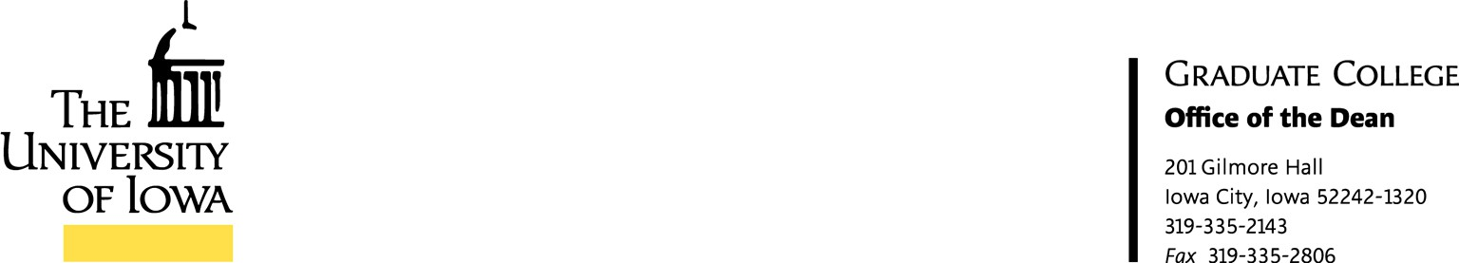

As you may know, the university is beginning the process of refreshing its existing strategic plan. In order to inform the new University plan, we have been asked to develop a Graduate College strategic plan.
The areas of focus that will make up the strategic plans of the collegiate, vice president (vp) units and the UI strategic plan are:
- Student success
- Research and discovery
- Diversity, equity and inclusion
- Engagement

While these focus areas are not new, their integration across units are vital to the future success of the UI’s students, faculty and staff. Moving forward, the Graduate College will form a steering committee of approximately 7-11 individuals with 2 co-chairs to represent the college.
The first step of the committee will be to understand the current status of the college, in comparison to the UI’s peer set. Utilizing a Strength, Weakness, Opportunities and Threats (SWOT) model, bringing information to the fore that will create a strategic plan designed to impact the future.
The steering committee will host at least 2 listening sessions, (and more if needed) to obtain feedback about:
- Identify areas of focus
- Identify opportunities for the college

Furthermore, the collegiate steering committee will engage with other collegiate/vp unit committees following the listening sessions in order to receive feedback about:
- The current collegiate/vp unit strategic plan
- Identify areas of focus
- Identify opportunities for the college/vp unit

Subsequent to the listening sessions, the steering committee will develop a draft collegiate strategic plan based upon the feedback and submit that draft to the President and Provost by February 3, 2020. Following the review from campus leadership, the collegiate steering committee will share the draft with the college and the steering

committee will host additional listening sessions to obtain feedback concerning the overall draft UI strategic plan.
The college’s steering committee will engage with existing collegiate/vp unit committees following the listening session in order to receive feedback about the draft strategic plan.
The steering committee will submit the final draft to campus leadership by May 1, 2020.

The strategic plan process is an opportunity for the community, through shared governance in every college and vp unit, to actively participate in the future. In order that the Graduate College can help develop the next steps towards building our future, I am asking you to nominate individuals (faculty, staff, and graduate students) who are knowledgeable about graduate education and willing to serve in this important role; self- nominations are encouraged. The Graduate College will receive steering committee nominations through September 30th (john-keller@uiowa.edu; or wendy- danger@uiowa.edu).
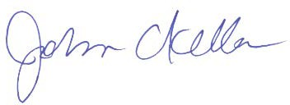
Thank you for your interest and participation. Sincerely,

John C. Keller
Associate Provost for Graduate & Professional Education Dean, the Graduate College

