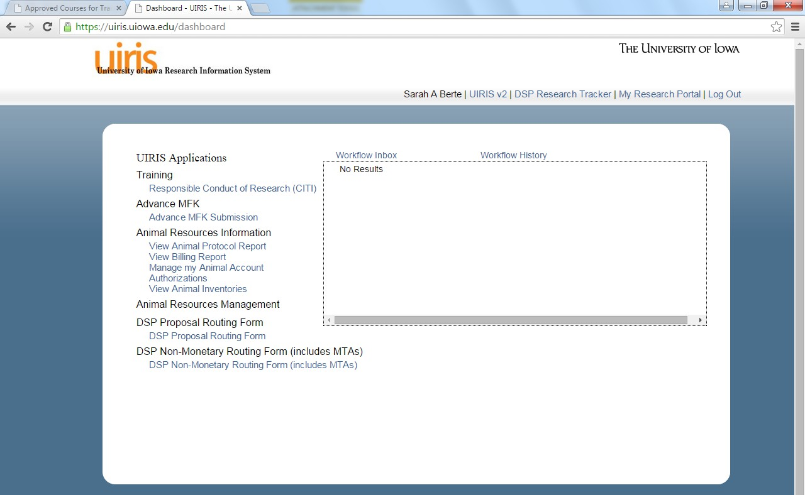
To access CITI training, please
visit: https://login.uiowa.edu/uip/login.page?service=https%3A%2F%2Fuiris.uiowa.edu%2Fse ssions%2F
- Once logged in, choose Responsible Conduct of Research (CITI) under “Training.”

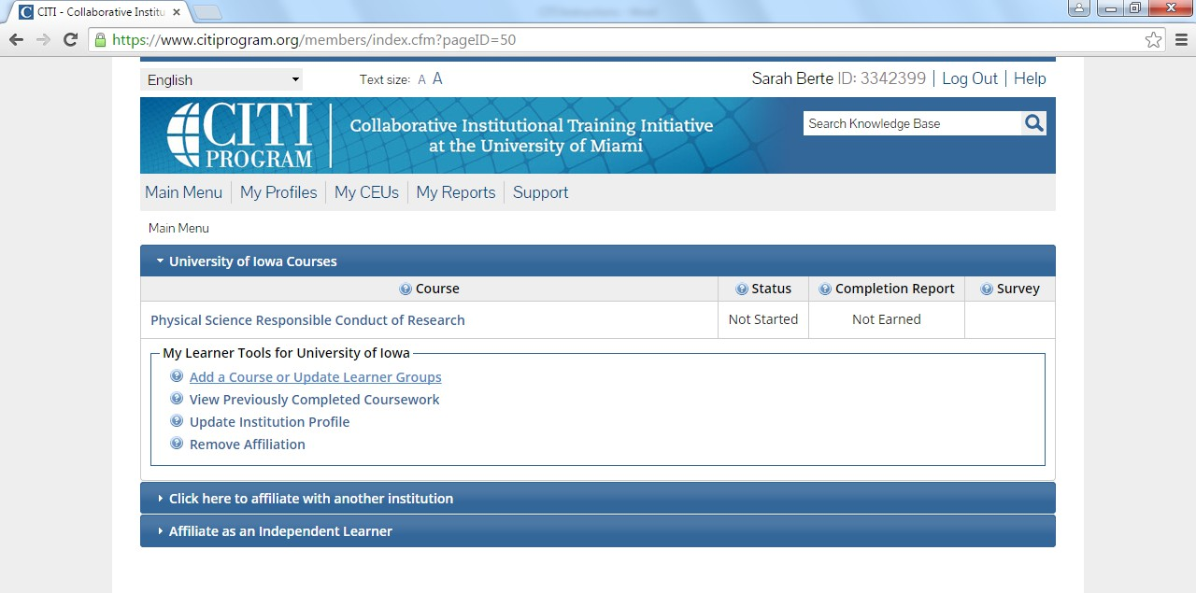
- Click “Add a course or update your learner groups”.

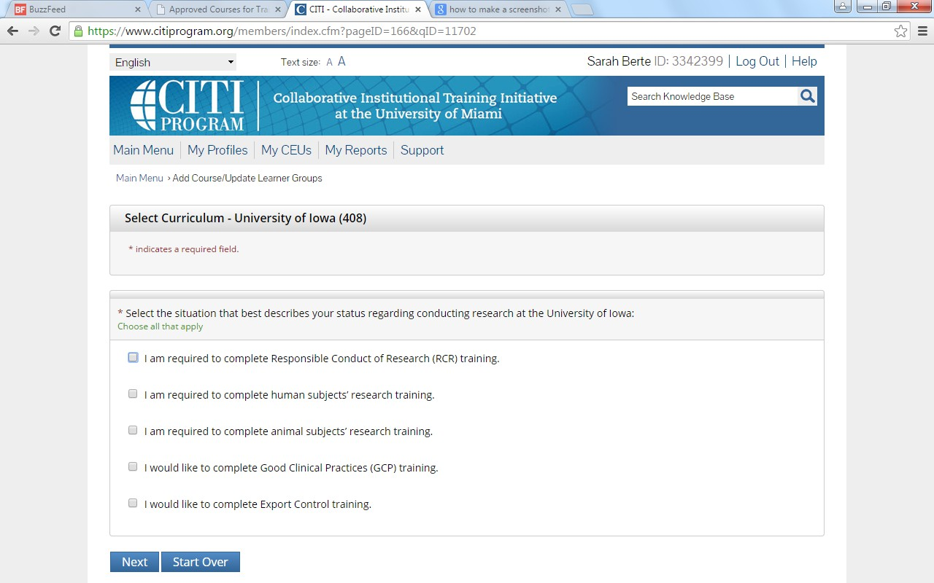
- Check box “I am required to complete Responsible Conduct of Research (RCR) training”.

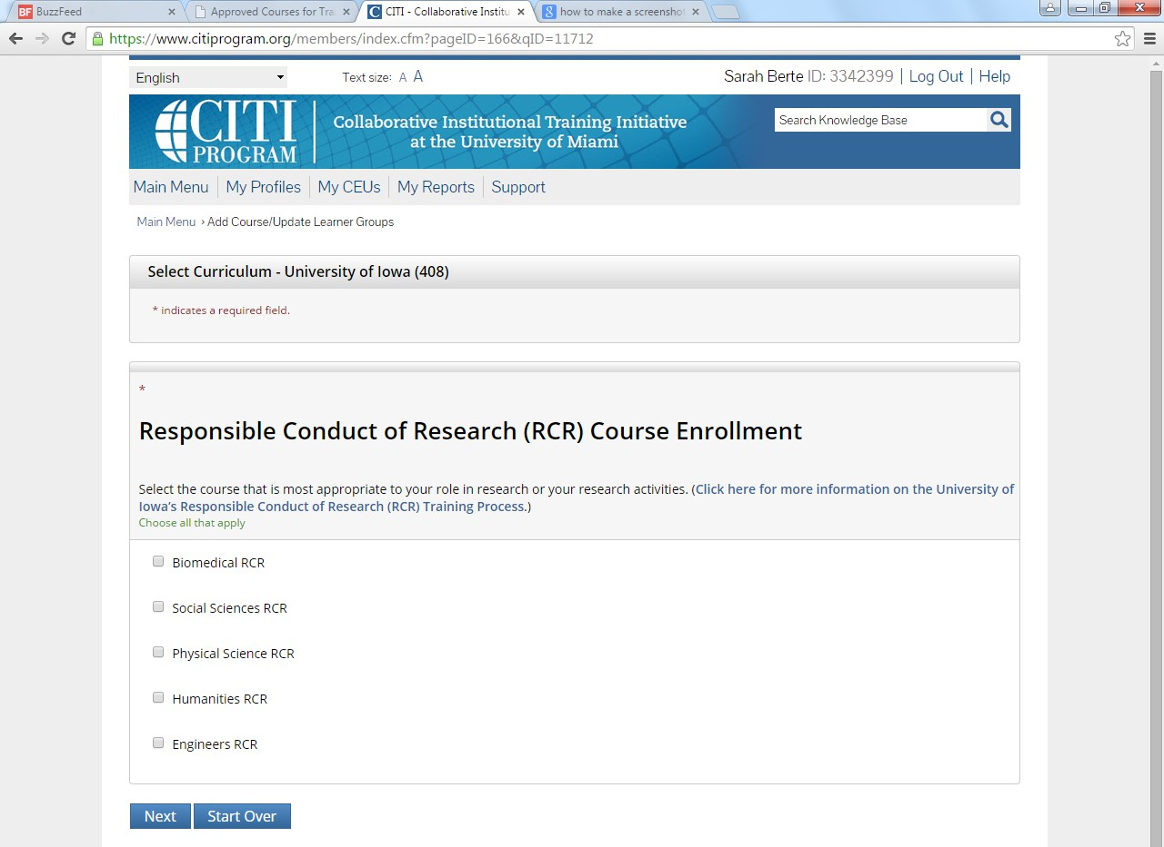
- Check box most appropriate to your role in research.

- Option to take pre-test
- Agree to Assurance Statement
- Complete the following modules (you must score at least 80% for each quiz, and should retake any quizzes for which you do not score 80%):
  - Responsible Conduct of Research: Course Introduction
  - Research Misconduct
  - Data Management
  - Authorship
  - Peer Review
  - Mentoring
  - Using Animal Subjects in Research
  - Conflicts of Interest
  - Collaborative Research
  - Researching Involving Human Subjects
  - Responsible Conduct of Research: Course Conclusion
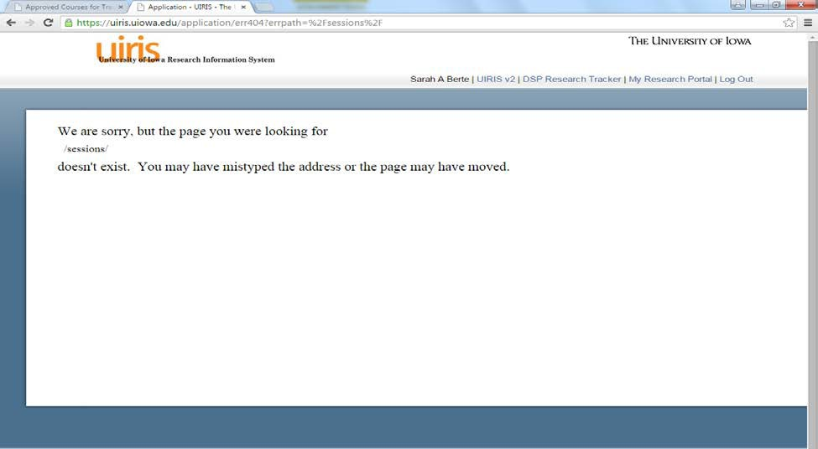
- Once you have completed the required modules, please forward your completion report and a screen shot showing scores of 80% or greater on each module to shelly-campo@uiowa.edu.
Students who begin CITI and then exit the browser to complete CITI another time, may encounter this page when they log in a second time. To return to CITI, click on the “uiris Unitversity of Iowa Research Information System”. It may ask you to log in again, but will return you to CITI from the second log in.

