Your Thesis Title Goes Here:
Either Single or Double Spaced

by

Center your name here

A thesis submitted in partial fulfillment
of the requirements for the
Master of Science / Master of Arts / Master of Fine Arts / Doctor of Philosophy
degree in Your Program in the
Graduate College of
The University of Iowa

Month and Year of Graduation

Thesis Committee: Name of Thesis Supervisor, Thesis Supervisor
Committee Member Name
Committee Member Name
Committee Member Name
Committee Member Name

Copyright by

CENTER YOUR NAME HERE

2022

All Rights Reserved

THIS PAGE IS OPTIONAL
To (Prior to your first thesis deposit, delete this text and type your dedication here. The entire dedication should be single spaced and centered vertically and horizontally on the page. This text may be altered between first and final deposit.)

THIS PAGE IS OPTIONAL

Prior to thesis deposit, delete this text and type your epigraph here. Each line should be centered, single spaced, and the entire text centered vertically. This text may be altered between first and final deposits.

Type author’s name here
Type title of work here

THIS PAGE IS OPTIONAL

ACKNOWLEDGMENTS
Prior to your first thesis deposit, replace this text with your acknowledgements. This text should be double spaced and each paragraph should be indented.

THIS PAGE IS OPTIONAL
ABSTRACT
Prior to your first thesis deposit, replace this text with the text of your scientific / scholarly abstract. The text of this abstract should be double spaced and each new paragraph should be indented.

This abstract is required for everyone except DMA and MFA students.
PUBLIC ABSTRACT
Prior to your first thesis deposit, replace this text with the text of your public abstract. The text of this abstract should be double spaced and each new paragraph should be indented. This abstract is required for all thesis/dissertations.
This abstract may be up to 250 words and should be written for a non-academic lay audience. In writing your public abstract, avoid jargon and technical language as much as possible.
The ability to communicate research simply and clearly is an important skill when interviewing for faculty positions, as well as for positions in industry and other sectors. The public abstract helps convey ideas beyond one’s immediate academic circle, facilitating communication with colleagues who do different kinds of work and possess different dimensions of training.
Think of your public abstract as your “elevator pitch” or what you might tell someone who asks, “What is your thesis about?” You may only have a few minutes to explain it to them while keeping their attention and using terminology you are sure they will understand without further lengthy explanation.
Another way to think of your public abstract is like the description you would read on the inside of a book cover.
TABLE OF CONTENTS
If you have used Styles in the thesis (see below), you will be able to generate a Table of Contents automatically. The Table of Contents includes three preset Styles: TOC 1, TOC 2, and TOC 3. TOC 1 corresponds to Heading 1, TOC 2 corresponds to Heading 2, and TOC 3 corresponds to Heading 3. The Table of Contents entries are formatted to help you meet the formatting requirements of the Graduate College.
To generate your Table of Contents, make sure that you have applied the Heading 1, Heading 2, and Heading 3 styles in the body of the thesis. Then, go to Insert, Index and Tables, Table of Contents, and click OK. A sample Table of Contents follows:
LIST OF TABLES viii
LIST OF FIGURES ix
PREFACE x
HEADING 1: INFORMATION ON HOW TO FORMAT YOUR MAJOR HEADINGS 1
Heading 2: Use For Your Broadest Subheading Level, Centered, Bold, Uppercase and Lowercase 1
Heading 3: Use For Your Next Heading Level, Left-aligned, Bold, Uppercase and Lowercase 2
Information on Tables 2
Information on Figures 3
REFERENCES 5
APPENDIX 6

LIST OF TABLES
Table 1. Student Information to Show How to Caption a Table. Go to Insert, Caption, and then Choose Table. Add the Caption Text in the Caption Text Box. 2
Table 2. Once You've Captioned Your Tables, You Are Ready to Generate Your List of Tables. 2
Table 3. Go to the Insert, Index and Tables, Table of Figures, and then Choose Table as the Caption Label. Your List Should Appear. 3

LIST OF FIGURES
Figure 1. To generate a caption, go to Insert, and then Caption. 3
Figure 2. Choose Figure, and enter your text. 3
Figure 3. Go to Insert, Index and Tables, Table of Figures, and then choose Figure as the caption label. Your list should appear. 4

PREFACE
Prior to your first deposit, replace this text with the text of your Preface. The Preface should be double spaced and new paragraphs should be indented.

THIS PAGE IS OPTIONAL

HEADING 1: INFORMATION ON HOW TO FORMAT YOUR MAJOR HEADINGS
Heading 1 is the style you should use for the following headings in your thesis: List of Tables, List of Figures (List of Abbreviations, Schemes, and so on), Chapter titles, References, and Appendix titles. If you are writing in APA style, note that the titles formatted as Heading 1 do not count as an APA heading.
To assign this heading level, type the heading text (fully capitalized), highlight it, and click on Heading 1 in the ribbon at the top of the page.
If you want to change the appearance of Heading 1, do so in the Styles ribbon at the top of the page (right click on Heading 1, and go to Modify). That way, all of your headings will be uniform.
If you want your headings to automatically number the chapters and sections of each chapter, make an appointment to discuss heading layout.

Heading 2: Use For Your Broadest Subheading Level, Centered, Bold, Uppercase and Lowercase
Heading 2 is the first major subheading style. If you are writing in APA style, this heading corresponds to a Level 1 APA heading. To assign this heading level, type the heading text, highlight it, and click on Heading 2 in the ribbon at the top of the page.
If you want to change the appearance of Heading 2, do so in the Styles ribbon at the top of the page (right click on Heading 2, and go to Modify). That way, all of your headings will be uniform.

Heading 3: Use For Your Next Heading Level, Left-aligned, Bold, Uppercase and Lowercase
Heading 3 is the second major subheading style. If you are writing in APA style, this heading corresponds to a Level 2 APA heading. To assign this heading level, type the heading text, highlight it, and click on Heading 3 in the ribbon at the top of the page.
If you want to change the appearance of Heading 3, do so in the Styles ribbon at the top of the page (right click on Heading 3, and go to Modify). That way, all of your headings will be uniform.

Heading 4: This heading is indented, bold, lowercase
This is an additional heading level, should your thesis require this level of specificity.

Information on Tables
Table 1. Student Information to Show How to Caption a Table. Go to Insert, Caption, and then Choose Table. Add the Caption Text in the Caption Text Box.
 | Column 1 | Column 2 | Column 3 | Column 4 | Column 5 | Column 6
Row 1
Row 2

Table 2. Once You've Captioned Your Tables, You Are Ready to Generate Your List of Tables.
 | Column 1 | Column 2 | Column 3 | Column 4 | Column 5 | Column 6
Row 1
Row 2

Table 3. Go to the Insert, Index and Tables, Table of Figures, and then Choose Table as the Caption Label. Your List Should Appear.
 | Column 1 | Column 2 | Column 3 | Column 4 | Column 5 | Column 6
Row 1
Row 2

Information on Figures
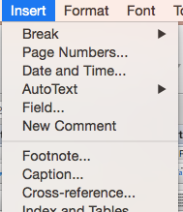
Figure 1. To generate a caption, go to Insert, and then Caption.
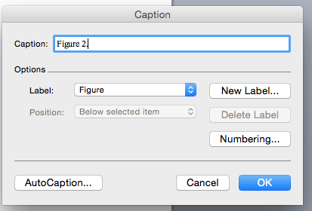
Figure 2. Choose Figure, and enter your text.

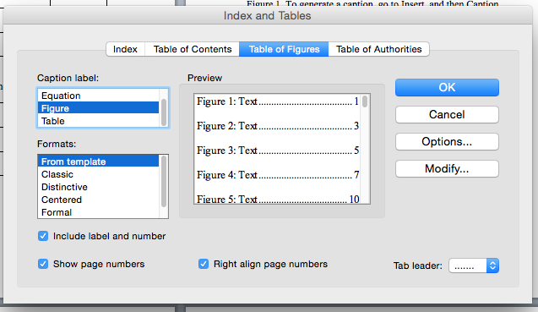
Figure 3. Go to Insert, Index and Tables, Table of Figures, and then choose Figure as the caption label. Your list should appear.

REFERENCES
The References heading is formatted as a Heading 1. Make sure each entry is formatted consistently, using the same indentation and spacing throughout.

APPENDIX
The Appendix (A, B, and so on) heading is formatted as a Heading 1. Note that if you only include one Appendix, you do not need to assign it a letter.

